Table of Contents

Analysis 3

Problem identification 3

Stakeholders 3

Research 4

Coding game 4

CS-Playground-React 5

Teaching Kids Computer Programming 6

Online Judging system 6

UK Bebras challenge 7

Ticket to Ride – a board game 8

An Educational Game for Teaching Search Algorithms 9

Brief conclusion 9

Essential features 10

Limitations 10

Requirements 11

Success criteria 15

Design 15

Top-Down Design 15

Interface design 17

Level Selection 18

General layout of a level 19

Save the princess 21

Shortest path 22

Knapsack problem 23

Usability 24

Classes and data structures 24

Inheritance diagram 24

Class diagram 25

Pseudocode algorithms 29

Puzzle 1: save the princess 29

Puzzle 2: shortest path 33

Puzzle 3: knapsack problem 37

Testing design 39

Developing and testing 42

Stage1: puzzle1 42

Maze generation 42

Player movement 46

Information display 49

Button functions 51

Solution in BFS 53

Review 57

Stage2: puzzle2 58

Graph generation 58

Edges and nodes display 60

Information display 63

Button functions 65

Solution in Dijkstra’s 68

Review 70

Stage3: puzzle3 71

Bag and items generation 71

Click to select and deselect 74

Information display 77

Button functions 79

Solution in DP 80

Review 82

Final stage: puzzle selection 83

Review 85

Evaluation 86

Success criteria (must) 86

Clear instruction on how to play the game 86

Player movement 87

All information required is displayed 90

Game running correctly and logically 91

Puzzles are chosen based on how classic and how often they are used to solve problems 94

Idea of OO is used properly throughout 94

Desirable features (should and could) 95

Solutions are straightforward for players to follow 95

Having seen a similar problem is helpful but not essential to be able to play 97

Future development 97

Usability features 98

Limitations and maintenance 103

Issues 103

How to address them 104

# Analysis

## Problem identification

There already exists lots of educational games of different kinds that can give beginners in computer science a brief introduction to what is computer science, but there are very few such games for intermediate or more advanced learners. Despite the fact that most advanced learners are driven by their own motivation rather than the fun from playing games, it would still be useful for them to have some sort of visualisations of some abstract concepts, as it is often the case that some of the algorithmic ideas in computing are rather abstract and can easily deter a new learner from further study.

Having realised that, my project is going to be writing an educational game using Python and its extension library Pygame. The game will try to illustrate some advanced computing algorithms that may or may not be taught in A Level Computer Science. The idea is that some algorithmic problems all have a very interesting story, behind which lies the complicated algorithms. So, I would like to illustrate these algorithms vividly for learners and hopefully this could encourage more people to learn these algorithms, which might seem quite daunting at first.

This problem is amenable to a computational approach due to two reasons. The first one is the nature of a game. As one of the aims of this project is to present computational ideas graphically and interactively, a computer would be necessary and sufficient to provide a platform for the user because it can output some game information through the monitor and receive input from the user to do the processing. Moreover, as the theme of this game is computing theory, it would make more sense if a player is playing this game on a computer. It could also make it easier for a user to implement these algorithms if he/she is sitting in front of a computer. Being able to access the source code of the game is also a good way to better understand the implementation. Compiling a book about these theories might be an alternative but would be less interactive and interesting to the learner.

## Stakeholders

Despite every effort is made to ensure this game is as interesting as possible, this game is not designed for absolute beginners who want to learn more about what computer science is, the reason of which is that this game assumes basic knowledge in computing such as a tree in graph theory and it does not include introductions to these theories. If a user wants to learn more about the implementation of an algorithm, programming knowledge may be needed. However, it is still possible for a learner to get a taste of advanced algorithms, although this game is not designed to do so. In conclusion, there are two main possible types of stakeholders:

1. Those who have already obtained some basic concepts of algorithms and want to study further in this area, then this game would be a good starting point to get a feeling;
2. Teachers might want to utilise this game in lessons while introducing relevant topics in order to add more fun to lessons. As each level in my game will centre around a key algorithm, e.g. dynamic programming, therefore this game can be played when a certain topic will be discussed in a particular lesson.

This game can be suitable to the two types of stakeholders described above due to two reasons. Firstly, it does not include those most basic ideas of programming, which is not needed if users have already obtained some level of programming knowledge. Secondly, it will focus more on the visualisation and principle of the algorithms and problems, which is more important than those basic ideas such as what is a variable to those more advanced learners. As to the teaching use of this game, the teacher can give students a basic idea of the knowledge needed to play this game.

## Research

### Coding game

Creating interesting game background to help leaners learn coding from scratch

Competitions similar to OJ but multi-player

Different types of games to improve coding skills

Lacks knowledge of some advanced algorithms

Fancy visual effects are used as an illustration of some rather abstract ideas in programming which makes this platform quite fascinating for new coders who want to make a start. However, most of the content is for beginners who rather than experienced programmers. They also offer multi-player competitions where one can challenge friends, schoolmates or coworkers, which is fun and engaging, but there is less visualisation in some of the higher level problems. In addition, those coding challenges are less difficult than those on lots of OJ platforms.

<https://www.codingame.com/start>



### CS-Playground-React

A simple in-browser JavaScript sandbox for learning and practicing algorithms and data structures, lots of classic sorting algorithms as well as data structures that are frequently used are included in this platform. Some challenges are provided at the end to test one’s knowledge and make it more fun. In addition, it also offers solutions when one gets stuck, and comes chock-full of links to helpful articles, tutorials, and other resources but that is provided as an external link which makes it less interactive. In conclusion, this website does teach you some very important data structures and algorithms but not in a game context.

<http://cs-playground-react.surge.sh/>



### Teaching Kids Computer Programming

There are lots of introductory games for kids as a taste of programming, for example, the Scratch programming language. And this website also offers 6 free games for teaching kinds programming. Although these games are very interesting and easy to play, they are designed to be a very brief introduction to programming which is not what I intended to do.

<https://educators.brainpop.com/2014/09/26/6-free-games-teaching-computer-programming-kids/>



### Online Judging system

<https://uva.onlinejudge.org/>

<https://leetcode.com/>

<http://codeforces.com/> 

These are all very well-known online judge systems where programmers can practice solving algorithmic problems and submit their solutions to judging systems. Feedback can normally be given in a few seconds. Some competitions may also be held regularly on these platforms. They are all perfect places to improve coding skills, but those problems are all designed by experts and tend to be very challenging. And it is often the case that there is no visualisation of problems available on these websites, which makes solving these problems even harder.

### UK Bebras challenge

This challenge is held annually and introduces computational thinking to students in different age groups. The main part of this challenge is to solve puzzles that require logical thinking rather than prior knowledge in computer science. Web-based human interaction is also available so that the participant can interact with the computer to obtain the solution.

<http://www.bebras.uk/students.html>



### Ticket to Ride – a board game

*Ticket to Ride* is a cross-country train adventure where players collect cards of various types of train cars that enable them to claim railway routes connecting cities in various countries around the world.

Students through the missions that they choose about connecting one city to another, come across the implementation of some path finding and minimum spanning tree algorithms, such as Kruskal’s, Prim’s and Dijkstra’s algorithm.

<https://www.daysofwonder.com/tickettoride/en/>



### An Educational Game for Teaching Search Algorithms

This is an article about using a Pacman game designed by the university team to teach searching algorithms such as DFS, A*, etc. This game consists of detailed explanations and visualisations of these algorithms in a game context. Students who play this game will also have the chance to apply their knowledge in this game in order to solve some of the challenges in this game.



### Brief conclusion

Having done the research, I realised that there are some similar platforms and projects that are committing to the visualisation of algorithmic problems, though with various approaches and levels. For instance, coding game has fascinating game context for new coders and makes it much more appealing to beginners, while online judging systems provides much more challenging and well-designed problems and feedback on users’ solutions after they submit their codes but most of the time visualisations are not available. If we go back to my initial thought, I intended to combine interesting stories and abstract computational ideas together to make the learning process less painful. This idea is similar to the game mentioned in the article An Educational Game for Teaching Search Algorithms. The game comes with explanations of great details and vivid illustration. Human interaction is achieved by asking students to apply what they learned in another mode of the game. This is the closest solution to my problem and thought, but there is still something to add.

## Essential features

In the project mentioned above, only searching algorithms are included and they are all demonstrated in the same game. (which does have some advantages) I want to add more algorithms of different categories and different games might be used to introduce different algorithms. It will consist of three features:

1. The game is a combination of OJ and the game “Pacman for teaching search algorithms”, two of the existing solutions to my problem. Therefore, most of my games will be based on problems from online judging systems (might be abstracted or decomposed). In other words, OJ problems will be visualised in my game. This is due to the fact that lots of problems from OJ are described as games or puzzles themselves, which already adds fun to my game and makes it easier to adapt them. In addition, qualities of problems from OJ are generally very good and I will also try my best to select the most classic ones to ensure leaners can have a good learning experience.
2. There are a range of games included in my project and most of them will have different levels of difficulty. Brute force may be able to address some of the easiest levels but will become too inefficient to be used while coping with harder levels. This design is based on the idea that efficiency is usually the key part of an algorithm design when the data scale becomes very large, which is often the case in the real world.
3. Last but not least, this game will be able to run offline. Bizarrely, nearly all existing solutions require users to have a stable Internet connection. Although publishing a game online will make it accessible to more people, being able to run offline gives users the opportunity to access it anywhere and anytime they like. And the game could run more smoothly on a local computer.

## Limitations

There are two main limitations of my solution. The first one is that the formal theories behind each game is not included in this game and users will have to find out themselves how exactly a problem is solved by a computational method and how this method is developed step by step. The reason why theories are not included is that there are already lots of excellent books or websites available, designed by expert computer scientists, and they tend to be very good resources for learning theories. The main focus of this game is to provide visualisation which can assist learners in their learning process and it is not meant to be a replacement of further study on those theories. This game is therefore not suitable to be used as a full learning guide.

The second limitation is that the visual effect of this game will not be as good as that on some of other platforms which appeared in the research. Although effort will be made to demonstrate the functionality of algorithms as much as possible, fancy visual effect is not the main concentration of this game. Some of the games may have already done the abstraction and may be presented to the user in a different way from how its original description is. This could potentially make the game less interesting to play for some of the users.

## Requirements

|  |  |  |  |
| --- | --- | --- | --- |
| No. | Description | Comments | priority |
| Design | | | |
|  | Clear instruction on how to play the game | So that a user can easily start to crack on the game | Must |
|  | Player movement | The player is able to move | Must |
|  | All information required is displayed | So that the user is able to play the game | Must |
|  | Game running correctly and logically | e.g. illegal moves are not allowed | Must |
|  | Problem illustration as straightforward as possible | Many of games in my project will be a simplified version of some rather complicated problems, so it is important to give clear illustration | Must |
|  | Having seen a similar problem is helpful but not essential to be able to play | A game level might not contain detailed explanation or tutorials such as examples on how to operate, but operations will be designed so that most users can figure them out intuitively | Should |
|  | Extra guidance provided if a user does not understand the problem | If a user is having difficulty on how to play the game or understanding the problem, there will be extra help available | Could |
|  | Challenges are offered in various levels of difficulty | So that users can build up knowledge and understanding of an algorithm | Should |
|  | Some illustrations of characters are included | To add more fun to the learning process | Could |
|  |  |  |  |
|  |  |  |  |
| User experience | | | |
|  | Game can run smoothly and provides good user experience | Smooth running can give the user the willingness to keep playing | Should |
|  | Program does not contain serious bugs | So that the game will not crush unexpectedly in most situations | Should |
|  | Essential functions are implemented and available to the user | e.g. the user does not need to start the game again if he/she took a wrong step as undo button is provided | Must |
|  |  |  |  |
| Educational aspect | | | |
|  | The user needs to think strategically in order to pass the game | As the primary purpose of this game to help user learn knowledge | Must |
|  | The game is as interactive as possible | So that user will not give up the game easily if he/she is stuck | Could |
|  | This game can encourage people to learn more about these algorithms rather than deter them | Another main focus of this project is to make the learning process of some complex algorithms more enjoyable, therefore the game is designed to motivate learners | Should |
|  | Solutions are straightforward for players to follow | Although explanations on how a solution is achieved will not be included, the correct answer will be displayed and made easy for a user to follow | Should |
|  | Principles behind games are logically strict | Since this game has educational purposes for advanced intermediate and advanced learners, it is vital to ensure the principles are accurate and logical | Must |
|  | Stories are interesting to most players | Again, this can make a user enjoy more about the learning process | Could |
|  | Puzzles are chosen based on how classic and how often they are used to solve problems | There is not much point for a programmer who is not very experienced to learn algorithms that are less often used | Must |
|  |  |  |  |
| Code itself | | | |
|  | Idea of OO is used properly throughout | There are lots of ideas in object-orientated programming, e.g. class, inheritance, private, etc. These ideas should be used accurately and correctly in the code. | Must |
|  | Code is as elegant as possible | So that is would be easier for others and to read | Could |
|  | Code is nicely commented | To make review process easier and more efficient | Could |
|  |  |  |  |
| Stakeholders’ requirement | | |  |
|  | Puzzles are carefully selected so that they are neither too obscure nor too basic. | By basic, they refer to algorithms such as binary search, while the network flow would be considered too advanced | Must |
|  | Puzzles are designed to deepen the understanding of algorithms rather than broaden the knowledge |  | Must |
|  | Puzzles are designed to as interesting as possible with some illustrations available | For example, some pictures could be used | Could |
| Others | | | |
|  | Hardware | A computer that is able to run this game would be sufficient. As this game does not take many CPU resources, nearly all computers nowadays will be able to run this game. |  |
|  | Software | Windows, macOS or Linux installed. These three operating systems support Python which is what this game is written, therefore it would be essential for a device to have one of these operating systems installed |  |
|  | Python interpreter | This is used to run the source code of this game. |  |
|  | Pygame library | This library provides lots of functionality that enable a programmer to write a game. My game will be mainly based on this library. |  |
|  |  |  |  |
|  |  |  |  |
|  |  |  |  |
|  |  |  |  |
|  |  |  |  |
|  |  |  |  |

## Success criteria

The success criteria are indicated with a must as their priorities in the requirements.

# Design

The game is divided into three different puzzles: breath-first search, shortest path and knapsack problem. Each of which is solved by a classic algorithm. These games are chosen based on my own programming experience. From the stakeholders’ point of view, they would also like the most classic challenges to start with rather than go directly into more advanced ones.

Some of these puzzles will be available in different levels of difficulty so that this can make the player apply knowledge to slightly unfamiliar situations and build up their understanding of the algorithms involved. It is also stated in the stakeholders’ requirement that the game is meant to deepen the understanding of algorithms.

## Top-Down Design

This is the overall structure of the game when broken down into smaller problems, and it also contains the order in which smaller problems are to be solved. More detailed description will be in the interface design.

Game project

Puzzle 3

Puzzle 2

Puzzle 1

Puzzle 2

Graph, player and target generated

Display edge when the mouse is over or the player is on

Edges and nodes drawn

Game information displayed

Button functions

Solution displayed graphically

Dijkstra’s algorithm to calculate the solution

Maze can be of different sizes

Node weight shown at the centre of the edge

Path taken highlighted

Puzzle 1

Maze, player and target generated

Maze can be of different sizes

Player blocked by wall and boundary

Movement of the player

Game information displayed

Button functions

Solution displayed graphically

Bfs to calculate the solution

Puzzle 3

Bag and items generated

Random generation of volume and weight

Right click to deselect items

Left click to select items

Game information displayed

Button functions

Solution displayed graphically

DP used to calculate the solution

Highlight selected items

## Interface design

### Level Selection

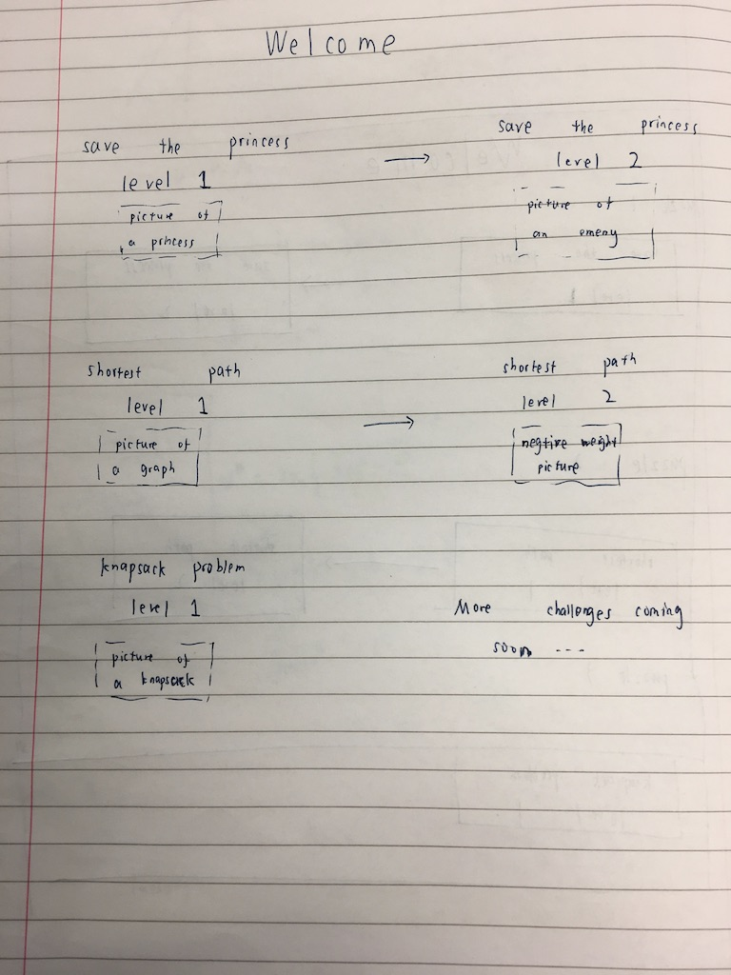

In the level selection interface design, different levels of the same challenge are offered to the user so that they can build up their understanding of the game step by step and it meets the requirement: “Challenges are offered in various levels of difficulty”.

Below every level that the user can select, there will also be a picture describing the feature that particular level. This is included such that the user can easily see the main characteristics of the level and they can come back if they wish to have another go at a particular challenge. It also makes sure that the game has a straightforward and vivid illustration, which is required in the success criteria and adds fun to the game itself.

### General layout of a level

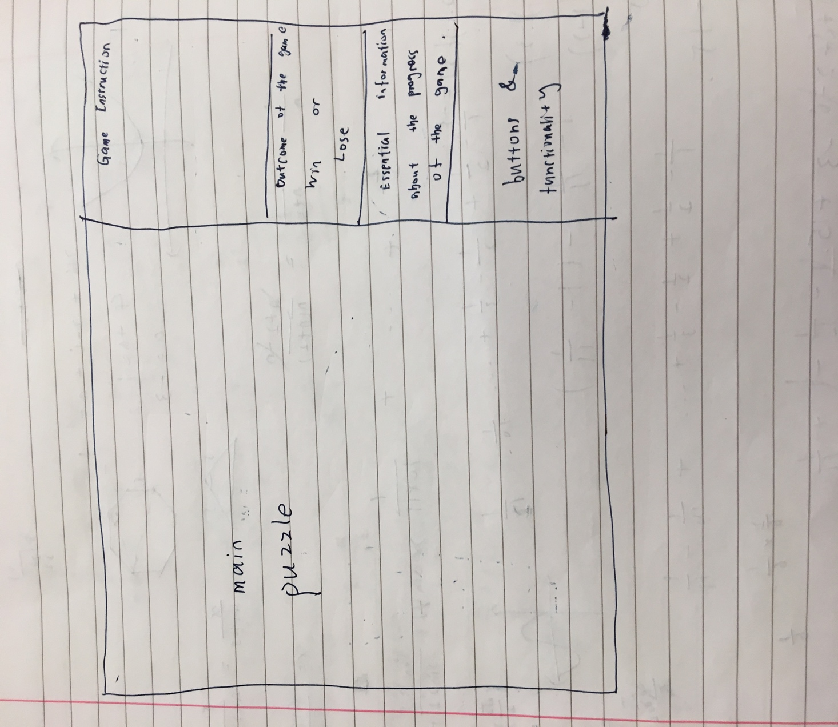

Generally, the screen is divided into two sections: the main puzzle, and the game information. The main puzzle section will obviously display the progress of the game graphically while the user is playing the game. And the information section gives essential information of the game which includes four parts:

* Game instruction: a brief introduction to the user on the objective of the game and how one could play the game;
* Outcome of the game: it shows whether the user has successfully accomplished the objective or there is a better solution to the game;
* Current progress of the game and the optimum solution: this will depend on the nature of the puzzle;
* Buttons: used to provide essential functionalities to the user. All puzzles will have three functions in common:

Retry – start the current puzzle again;

Restart – restart the current puzzle with different difficulties;

Display solution – solution of the puzzle will be displayed if this button is pressed.

### Puzzle1: Save the princess

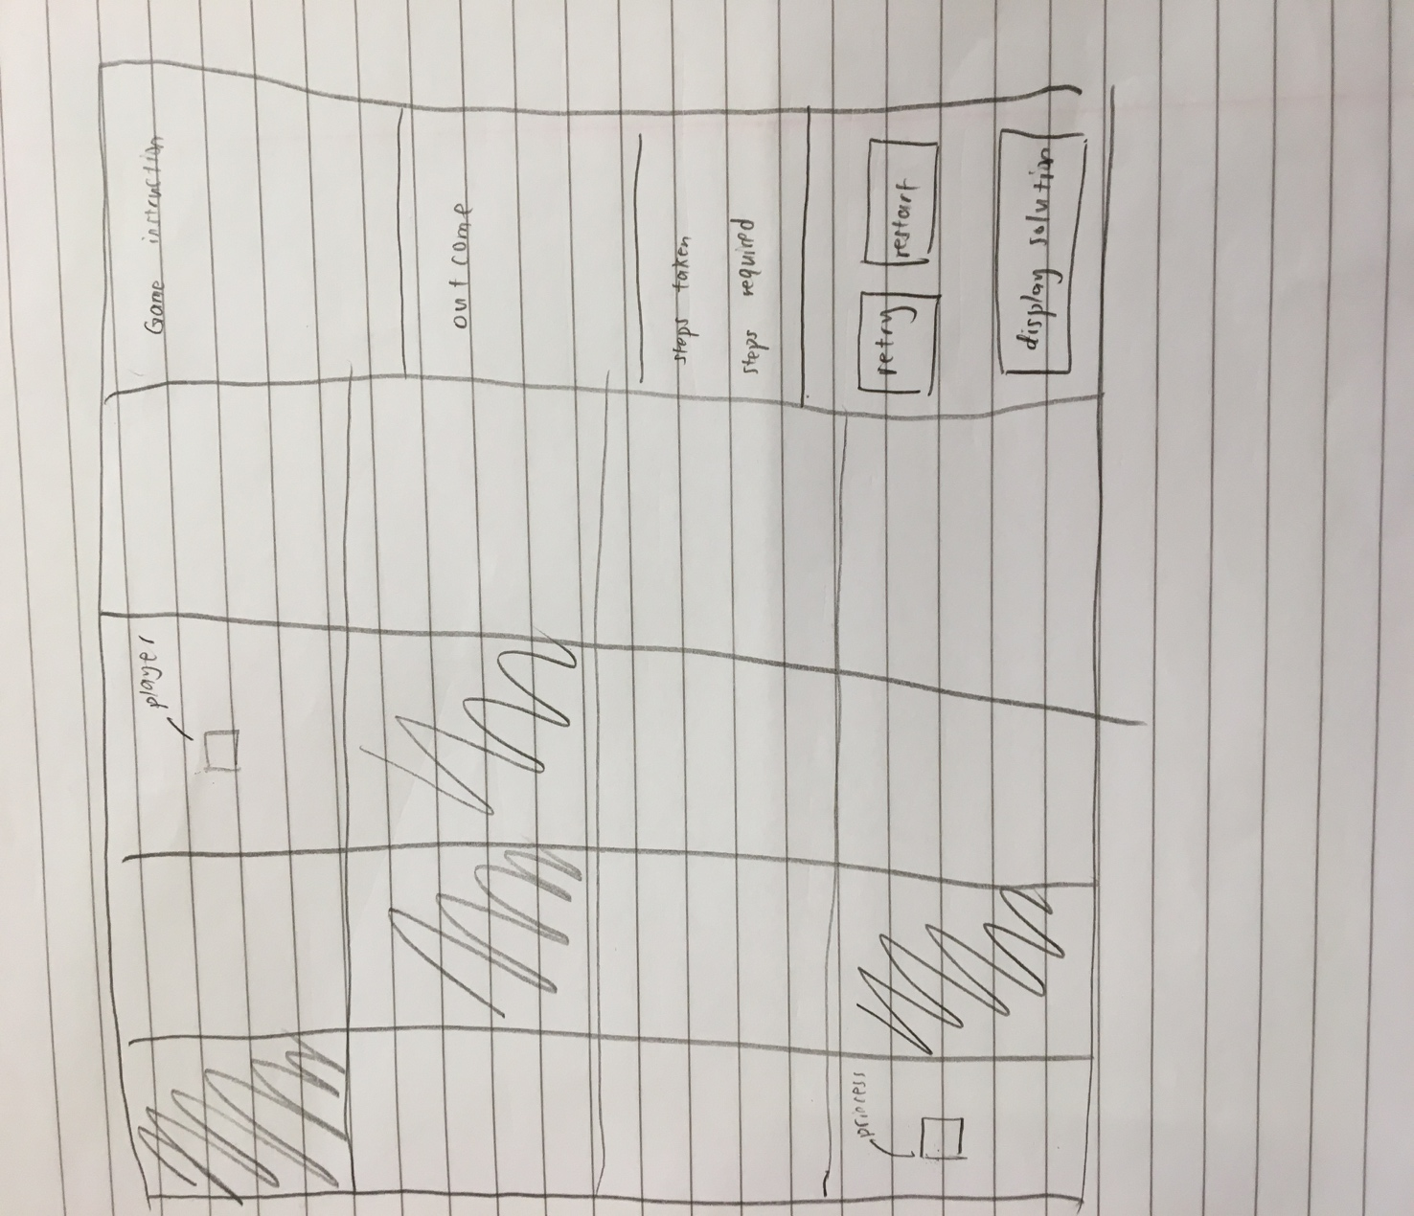

This is the “save the princess” challenge level 1, which is a classic application of breath-first search algorithm. The user needs to move the player to reach the princess in minimum number of steps. The maze consists of a number of cells where shaded ones are not reachable. The maze will be generated on a random basis and the size of it will change each time. This is to test the player’s understanding of the algorithm as opposed to memorise the solution. The player has to move across the maze and pass only those white squares. That is why, in the top down design, the player movement is included. On the right-hand side, basic information such as how many steps the user has taken and what is the minimum number of steps one could reach is shown to the user, so that one can have an idea of how close he/she is to the final solution. This puzzle has all three basic functions of all puzzles.

### Puzzle2: Shortest path

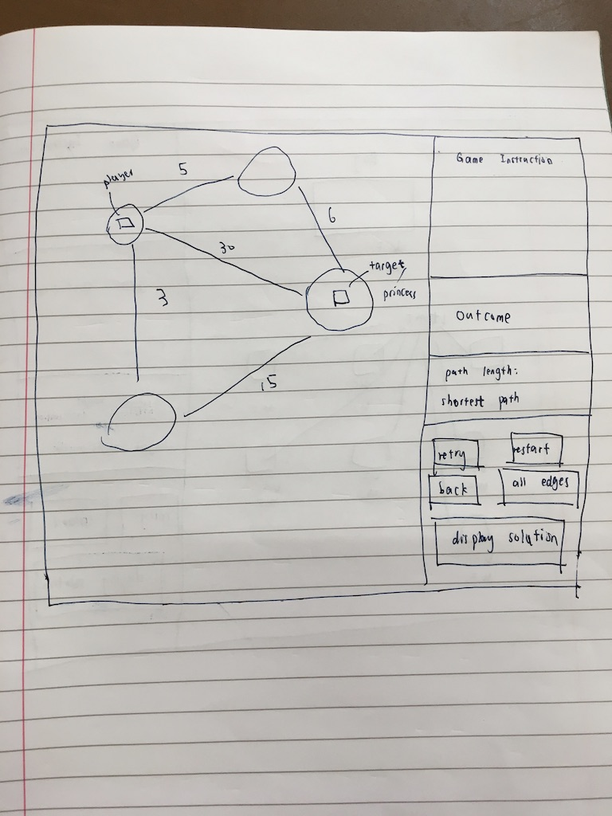

This is the second puzzle that requires the player to move from a starting node to the destination node with the shortest path on a graph. Again, the graph is randomly generated due to the same reason as in puzzle 1. It is also important the graph is displayed clearly and hence this is ensured by breaking it down into four smaller problems in the top down design. This puzzle is adapted from another classic shortest algorithm – Dijkstra’s algorithm. Some specific information of this game includes how long the path is that the user has taken and what is the optimum solution.

### Puzzle3: Knapsack problem

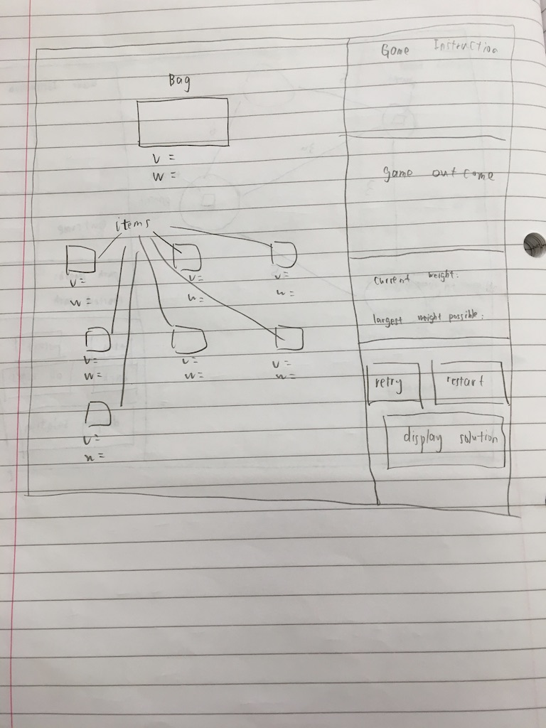

Again, the knapsack problem is well-known mathematical problem and also a perfect example for the programming technique – dynamic programming. In this challenge, the player needs to select items that they think will give the maximum overall weight within a limited volume. And apart from the basic puzzle generation, this puzzle is different from the previous two in that it involves select and deselect and hence it the selection is broken down into three steps.

## Usability

In terms of the usability of this game, various designs can be found to make the game more usable to a user. In terms of general elements that all puzzles have, the following can be considered to make the game more usable:

Game instruction designed to help a user get a basic understanding of the game;

Information can be found that is dynamically changing as the game progresses to help the user make decisions on what to do next;

Outcome of the game will also be displayed once the target has been reached and it can also give further advice on whether there is a better solution to be found;

Buttons are designed to give the user better experience while he/she is playing the game. For example, a user might want to restart the game if he/she made some mistakes or simply wants to try a new challenge. Graphical solutions are also available through the solution button.

There are also specific designs in each puzzle to ensure usability:

Puzzle1: Arrow keys to move the player in a maze, which would be quite straightforward for one to do when seeing something in a maze;

Puzzle2: Clicking the node to move the player can be quite an easy operation to recognise and it is also included in the game instruction. In addition to three basic functions that all games have, this puzzle has two extra ones—the back button and the all edges button. The back button allows the user to undo one movement, which is naturally someone wants to do if he/she makes a mistake and this is also one of the essential functions required in the success criteria. The all edges button will display all edges when it is pressed, which can give the user a general idea of what the whole graph is like;

Puzzle3: The user is able to not only select items they want to put into the bag, but also deselect by right clicking the item, which can make it much easier if the player changes his/her mind during the game. Highlighting selected items can help the user see at a glance what choices he/she has made and what is the next thing to choose.

The game information section is designed to ensure the usability of the game while also reflect the following requirements:

* Clear instruction on how to play the game, which is achieved by giving game instructions and showing current progress to the user;
* Having seen a similar problem is helpful but not essential to be able to play, as operations required to play the game are all very intuitive;
* Essential functions are implemented and available to the user.

## Classes and data structures

### Inheritance diagram

Now the different interface designs of the game are ready and it is time to go on to the code design. Based on the nature of a general level and the relationship between different puzzles, the following inheritance diagram is created accordingly:

Puzzle

Puzzle1

Puzzle2

Puzzle3

### Class diagram

Element

Pygame.sprite.Sprite

Bag

Item

Player2

Player1

NPC

Element

+image

-centre

-pos

-ori_pos

-rect

-cor

-ori_cor

-size

+tracking_event(keys)

+move(end_pos)

+set_pos(pos)

+set_cor(cor)

+set_size(size)

+get_cor()

+get_size()

+get_ori_pos()

+reset()

NPC

Player1

-step

+get_step()

Player2

-path

+move_back()

+get_path()

Item

-volume

-weight

-selected

+get_weight()

+get_volume()

+is_mouse_over()

+mouse_pressed()

+clicked()

+highlight()

+deselect()

Bag

-volume

-weight

-ori_v

+set_weight(w)

+set_volume(v)

+get_volume()

+get_weight()

Level

-solution

-buttion_list

+initialise()

+get_solution()

+display_info()

+restart()

+retry()

+pre_update()

+update()

Level1

+maze

+princess_cor

+maze_num

+tile_list

-retry_button

-restart_button

-solution_button

-my-player

-solution_list

+draw_tiles()

Level2

+node_num

+graph

+node_list

+visited_node

+princess_cor

-my_player

-retry_button

-restart_button

-back_button

-all_edges_button

-solution_button

+draw_nodes()

+draw_visited_node()

+draw_edges()

+draw_all_edges()

+draw_edges_from_node()

+back()

+display_all_edges()

Level3

+item_num

+item_list

-my_player

-retry_button

-restart_button

-solution_button

+display_weight_and_volume()

+item_highlight()

Button

-image

-rect

-word

-size

+is_over()

+is_pressed()

+display()

+switch(color)

+update()

Node

-radius

-centre

-color

-num

-weight

+is_mouse_over()

+get_centre()

+get_size()

+get_color()

+get_weight()

+get_num

+set_weight(w)

Tile

-image

-rect

-color

-centre

+set_color(color)

+get_color

+get_centre()

+get_rect()

## Pseudocode algorithms

Now that the overall structure and function of each class has been defined and the relationship between different classes has been specified, more specific algorithms and pseudocodes are needed to describe the solution in more detail.

As there are lots of similarities between different puzzles, only algorithms specific to a puzzle will be demonstrated in the pseudocode.

### Puzzle 1: save the princess

The initialise method allows the maze of puzzle 1 as well as the player and the princess to be generated ready for to be displayed. It is also possible to use this method to re-generate these elements for a new challenge. If this procedure is put into a class, it should be not the constructor of the class, and the reason for that is that a constructor will only be called once when an object is constructed, whereas the puzzle needs to be generated multiple times and with a different grid size each time, therefore writing a separate subroutine that can generate the maze randomly each time will be more suitable.

1. procedure initialise()
2. # 1=wall 2=player 3=princess
3. maze_num = random(5, 30)
4. maze = [maze_num, maze, nun]
5. tile_list = []
7. nSpecialElement = random(0, maze_num ^ 2 * 0.5)
8. # randrange [a,b), 60mod of the maze is wall
9. playerCor = random(0, maze_num ^ 2)
10. maze[playerCor // maze_num][playerCor mod maze_num] = 2
12. while **True**
13. princessCor = random(0, maze_num * maze_num)
14. if princessCor != playerCor
15. break
16. endif
17. endwhile
18. maze[princessCor // maze_num][princessCor mod maze_num] = 3
19. nSpecialElement -= 2
21. for i= 0 to nSpecialElement
23. while **True**
24. wallCor = random(0, maze_num * maze_num)
25. if wallCor != princessCor and wallCor != playerCor
26. break
27. endif
28. endwhile
29. maze[wallCor // maze_num][wallCor mod maze_num] = 1
30. next i
32. sideLength = 500 / maze_num
33. for i = 0 to maze_num
34. for j = 0 to maze_num
36. t = new Tile((j * sideLength, i * sideLength), (sideLength, sideLength))
38. if maze[i][j] == 1
39. t.set_color(0)
41. else if maze[i][j] == 2
42. size = [sideLength * 0.4,
43. sideLength * 0.4]  # the size of the player will make up two fifths of a tile
44. my_player = new Player1(t.get_centre(), [i, j], size, BLUE)  # player is centred
45. all_sprites_group.add(my_player)
47. else if maze[i][j] == 3
48. size = [sideLength * 0.4, sideLength * 0.4]
49. princess = new NPC(t.get_centre(), [i, j], size, RED)
50. all_sprites_group.add(princess)
51. princess_cor = [i, j]
53. tile_list[i][j] = t
54. endif
55. next i
56. endprocedure

The optimum solution is pre-calculated after the maze is generated and before the game starts. This is because it needs to be displayed on the screen once the maze has been generated to give the player a guide as to what needs to be achieved. This is calculated in the get_solution method. In this specific challenge, breath-first search is used to find the optimum solution. The reason of choosing this searching method this is based on two facts: 1. The graph is unweighted; 2. Optimum solution is required. Although there are other shortest path algorithms that will work on this type of graph, breath-first search is one of the easiest searching algorithms that can solve this problem.

1. procedure get_solution()
2. solution = -1
3. solution_list = []
4. q = []
5. qHead = 0
6. qTail = 0
7. # every element in q is a list of three integers s[0] row num, s[1]column number;
8. # s[2] number of steps, s[3] father
9. visited = [maze_num,maze_num]
10. dir = [[0, 1, 0, -1], [1, 0, -1, 0]]
11. startPos = my_player.get_cor()
12. endPos = princess_cor
13. q.append([startPos[0], startPos[1], 0, -1])
14. qTail += 1
15. while qHead != qTail
16. s = q[qHead]
17. if [s[0], s[1]] == endPos
18. solution = s[2]
19. father = qHead
20. while **True**
21. solution_list.append([q[father][0], q[father][1]])
22. father = q[father][3]
23. if father == -1
24. break
25. solution_list.reverse()
26. break
27. endif
28. for i = 0 to 3
29. new_r = s[0] + dir[0][i]
30. new_c = s[1] + dir[1][i]
31. if new_r < 0 or new_r >= maze_num or new_c < 0 or new_c >= maze_num or maze[new_r][
32. new_c] == 1 or visited[new_r][new_c]
33. continue
34. endif
35. q.append([new_r, new_c, s[2] + 1, qHead])
36. qTail += 1
37. visited[new_r][new_c] = 1
38. qHead += 1
39. next i
40. endwhile
41. endprocedure

### Puzzle 2: shortest path

The puzzle2 initialise has a similar function to that of the puzzle1: generating the graph and the player. For the same reason, a separate procedure is used in order to generate the graph multiple times. In order to make the graph look more random, the position of each node on the graph will also be generated on a random basis so that a user will not get tired of seeing the node in the same position each time he/she starts a new game. However, these positions cannot be entirely random as that will make the graph look messy and there is possibility that two nodes overlapping each other which can make the game hard to play. Therefore, the position of every node will be constrained in a certain region. This is achieved by dividing the whole screen into small squares.

1. procedure initialise()
2. node_num = random(3, 30)
3. # generate the position of every node
4. num = sqrt(node_num) + 1
5. sep = 500 / num
6. i = 0
7. j = 0
8. minR = 500
9. for k =0 to node_num
10. start_x = int((j + 0.1) * sep)  # leave some blank space
11. end_x = int((j + 0.9) * sep)
12. start_y = int((i + 0.1) * sep)
13. end_y = int((i + 0.9) * sep)
14. circlePos = [random(int(start_x + sep * 0.2), int(end_x - sep * 0.2)),
15. random(int(start_y + sep * 0.2), int(end_y - sep * 0.2))]
16. # make sure the node is not too small
17. radius = min(circlePos[0] - start_x, end_x - circlePos[0], circlePos[1] - start_y, end_y - circlePos[1])
18. minR = min(radius, minR)
19. node_list.append(new Node(circlePos, radius, k, DARKGREY))
20. j += 1
21. if j == num
22. i += 1
23. j %= num
24. endif
25. next k
27. # generate the graph in a adjacency list
28. graph = [node_num]
29. for i =0 to node_num
30. used = [node_num]
31. used[i] = 1
32. outDegree = random(1, int(node_num * 0.8))
33. j = 0
34. while j < outDegree
35. n = random(0, node_num)
36. if used[n]
37. continue
38. endif
39. used[n] = 1
40. j += 1
41. w = random(1, 100)
42. node = node_list[n]
43. node.set_weight(w)
44. graph[i].append(node)
45. endwhile
46. next i
48. # initialise the player
49. n1 = node_list[random(0, node_num)]
50. my_player =new Player2(n1.get_centre(), n1.num, [minR, minR], BLUE)
51. visited_node.append(n1)
52. all_sprites_group.add(my_player)
53. while **True**
54. n2 = node_list[random(0, node_num)]
55. if n2.num != n1.num
56. princess =new NPC(n2.get_centre(), n2.num, [n2.get_size(), n2.get_size()], RED)
57. all_sprites_group.add(princess)
58. princess_cor = n2.num
59. break
60. endif
61. endwhile
63. end procedure

The optimum solution in this level is calculated through the get_solution method and the Dijkstra’s algorithm is used. As opposed to the first puzzle, which is solved using breath-first search, but that algorithm cannot be applied to a weighted graph, hence Dijkstra’s is used instead as it is easy to implement and does work on a weighted graph.

The path may also need to be stored so that backtrack is possible.

1. procedure get_solution()  # find the optimum solution of a problem
2. solution_list = []
3. visited = [0] * node_num
4. dist = [INF] * node_num
5. prev = [0] * node_num
6. pq = PriorityQueue()
7. nd = node_list[my_player.get_cor()]
8. nd.set_weight(0)
9. pq.put(nd)
10. prev[nd.num] = -1
11. dist[nd.num] = 0
12. while not pq.empty()
13. nd = pq.pop()
14. if visited[nd.num]
15. continue
16. endif
17. if nd.num == princess_cor
18. solution = dist[nd.num]
19. father = nd.num
20. while **True**
21. solution_list.append(father)
22. if prev[father] == -1
23. break
24. endif
25. father = prev[father]
26. endwhile
27. solution_list.reverse()
28. break
29. endif
30. visited[nd.num] = 1
31. for i = 0 to len(graph[nd.num])
32. n = graph[nd.num][i]
33. if visited[n.num]
34. continue
35. endif
36. if dist[n.num] > dist[nd.num] + n.weight
37. dist[n.num] = dist[nd.num] + n.weight
38. prev[n.num] = nd.num
39. pq.enQueue(n)
40. endif
41. next i
42. endwhile
43. end procedure

### Puzzle 3: knapsack problem

Similarly, the initialise method is used to generate the bag and items in this puzzle. This time the initialise method is relatively simple compared to the previous two as the main focus of this puzzle is the mathematical principle used to solve the problem. The weight and volume of every element will still be generated randomly so that a user will be faced with different situations each time.

1. procedure initialise()
2. item_num = random(4, 30)
3. my_player = new Bag([250, 65], [100, 70], RED, random.randint(10, 100))
4. all_sprites_group.add(my_player)
5. num_x = int(sqrt(10 / 7 * item_num)) + 1
6. num_y = int(sqrt(7 / 10 * item_num)) + 1
7. sep_x = 500 / num_x
8. sep_y = 350 / num_y
9. i = 0
10. j = 0
11. for k = 0 to item_num-1
12. start_x = int((j + 0.3) * sep_x)
13. end_x = int((j + 0.7) * sep_x)
14. start_y = 150 + int((i + 0.3) * sep_y)
15. end_y = 150 + int((i + 0.7) * sep_y)
16. item_pos = [start_x, start_y]
17. size = [end_x - start_x, end_y - start_y]
18. v = random(5, 50)
19. w = random(1, 100)
20. item = new Item(item_pos, size, BLACK, v, w)
21. item_list.append(item)
22. all_sprites_group.add(item)
23. j += 1
24. if j == num_x
25. i += 1
26. j = j mod num_x
27. endif
28. next k
29. endprocedure

Dynamic programming is the technique used here to calculate the solution. Obviously, this problem can be solved using a brute force method – by listing all possibilities of combining items in a bag and examine the value obtained each time, which will take exponential time. Therefore, dynamic programming is chosen as an alternative method, which is a pseudo-polynomial time algorithm for this problem. This means that in most of the case it will solve the problem in a reasonable amount of time. Similar to the last puzzle, the actual combination of items may also need to be stored in order to be displayed on the screen.

1. procedure get_solution()  # find the optimum solution of a problem
2. w = [0] * (item_num + 1)
3. v = [0] * (item_num + 1)
4. for i = 1 to item_num
5. w[i] = item_list[i - 1].get_weight()  # i-1 is because index starts from 0 in the item_list
6. v[i] = item_list[i - 1].get_volume()
7. next i
8. dp = [my_player.volume + 1,item_num + 1]
9. choices = [my_player.volume + 1, item_num + 1]
10. # store how items are selected for dp[i][j]
11. for i =1 to item_num
12. for j =1 to my_player.get_volume()
13. dp[i][j] = dp[i - 1][j]
14. choices[i][j] = choices[i - 1][j]
15. if j >= v[i] and dp[i - 1][j - v[i]] + w[i] > dp[i - 1][j]
16. dp[i][j] = dp[i - 1][j - v[i]] + w[i]
17. choices[i][j] = choices[i - 1][j - v[i]] + [i]
18. endif
19. next j
20. next i
21. solution = dp[item_num][my_player.get_volume()]
22. solution_list = choices[item_num][my_player.get_volume()]
24. endprocedure

## Testing design

This game will be tested at various stages, each with a different aim. At the first stage, the game will be checked against the most important requirements (indicated by “must” in the success criteria) to make sure that it has all the basic elements running correctly. After the first test, the game is able to run properly with all the key features listed in the requirement.

|  |  |  |  |
| --- | --- | --- | --- |
| No. | Requirement | Design | Expected output |
|  | Level1 | | |
|  | Problem illustration as straightforward as possible | Maze generation | Maze is correctly generated and easy to operate on |
|  | Player movement | Arrow keys to move the player | Player moves accordingly |
|  | Clear instruction on how to play the game | Wining text displayed | Text are displayed when the game starts |
|  | Clear instruction on how to play the game | Steps taken change as player moves | As required by the design |
|  | Essential functions are implemented and available to the user | Retry button working | The game starts again with the same setting, e.g. the same map |
|  | Essential functions are implemented and available to the user | Restart button working | The game starts again with a different setting, |
|  | Essential functions are implemented and available to the user | Display solution button working | Solution displayed |
|  | Algorithm test | | |
|  | N/A | initialise method generates the maze and the player | The maze, player and target are ready when the game starts |
|  | N/A | get_solution method calculates the minimum steps required for the player to reach the target | Manual trace can be used to check the correctness of the algorithm |
| Level2 | | | |
|  | All information required is displayed | Edges and weights displayed | Text are displayed when the game starts |
|  | Player movement | Player able to move | Player moves when a node is clicked |
|  | Essential functions are implemented and available to the user | Edges displayed when mouse is over | As required in the design |
|  | Essential functions are implemented and available to the user | Path taken displayed | Trajectory is shown when the player moves |
|  | Game running correctly and logically | Player cannot move to a node that is connected | Player will not move when the user clicks a node that is not connected |
|  | Clear instruction on how to play the game | Game information displayed | Text are displayed when the game starts |
|  | Essential functions are implemented and available to the user | Retry button working | The game starts again with the same setting, e.g. the same graph |
|  | Essential functions are implemented and available to the user | Restart button working | The game starts again with a different setting, |
|  | Essential functions are implemented and available to the user | Display solution button working | Solution displayed |
|  | Essential functions are implemented and available to the user | Back button working | To undo the movement, click the undo button |
|  | Essential functions are implemented and available to the user | All edges button working | All edges are displayed when the button is clicked |
|  | Algorithm test | | |
|  | N/A | initialise method generates the maze and the player | The maze, player and target are ready when the game starts |
|  | N/A | get_solution method calculates the shortest path required for the player to reach the target | Manual trace can be used to check the correctness of the algorithm |
| Level3 | | | |
|  | All information required is displayed | Bags and items displayed | Text are displayed when the game starts |
|  | All information required is displayed | Weight and volume underneath | Text are displayed when the game starts |
|  | Clear instruction on how to play the game | Game instruction shown | Text are displayed when the game starts |
|  | Clear instruction on how to play the game | Game information changes dynamically | correct information is displayed when the game progresses |
|  | Essential functions are implemented and available to the user | Retry button working | The game starts again with the same setting, e.g. the bag is used |
|  | Essential functions are implemented and available to the user | Restart button working | The game starts again with a different setting, |
|  | Essential functions are implemented and available to the user | Display solution button working | Solution displayed |
|  | Essential functions are implemented and available to the user | To select items | Left click to select items and selected items are highlighted in green |
|  | Essential functions are implemented and available to the user | To deselect items | Right click to deselect items and green lines will disappear |
|  | Algorithm test | | |
|  | N/A | initialise method generates the bag and items | The bag and items are ready when the game starts |
|  | N/A | get_solution method calculates the largest weight possible for a given volume | Manual trace can be used to check the correctness of the algorithm |
|  |  |  |  |

Secondly, the game will be tested again according to the “should” requirements, as these ensure a good user experience while playing and that the objective of this game — illustrating abstract and complex computational algorithms as vividly as possible is achieved.

Finally, another check will be carried out against requirements followed by “could”. These are additional features that the game could have so that it is more interesting in terms of playability. All the basic functionalities and objectives will have been achieved by the previous tests.

# Developing and testing

Following on from the Design section, where the problem is decomposed into many small parts that can be solved individually, the actual implementation of this problem will be mostly based on how it is divided into small sections. There will be four main stages in this development, and every stage is broken down further into small tasks. Prototypes will be developed and tested against the requirement, and any improvements can be made if necessary.

## Stage1: puzzle1

According to the top down design section of the first puzzle, this puzzle is divided into eight parts, three of which are dependent on previous steps. The order of these solving these problems are not particularly important if there is no dependency between them.

### Maze generation

This game is based on a maze to run and it is required that the game needs to have straightforward illustrations, therefore, the first step to be implemented is to generate the maze, player and the target.

The maze will be implemented as a 2d array where 1s will represent free squares and 0s will be used when a square is blocked, i.e. the player cannot move onto it, and it is shown in black on the image below. Positions of blocked squares will be randomly generated so that the game can be played many times. The position of the player and the target will also be randomly generated and an object of the player and the target will be generated on the designated position.

This is achieved by the following code:

**def** generate_maze(): *# in addition to generate the maze and add it to groups, also returns the myPlayer object  
 # 1=wall 2=player 3=princess* **global** maze  
 nMazeNum = 30  
 maze = [[0] * nMazeNum **for** i **in** range(nMazeNum)]  
 princessPos = [0, 0]  
 nSpecialElement = random.randrange(0, int(nMazeNum * nMazeNum * 0.6)) *# randrange [a,b)* playerCor = random.randrange(0, nMazeNum * nMazeNum)  
 maze[playerCor // nMazeNum][playerCor % nMazeNum] = 2  
 **while True**:  
 princessCor = random.randrange(0, nMazeNum * nMazeNum)  
 **if** princessCor != playerCor:  
 **break** maze[princessCor // nMazeNum][princessCor % nMazeNum] = 3  
 nSpecialElement -= 2  
 print(**"nSpecialElemen="**, nSpecialElement, **"nMazeNum="**, nMazeNum)  
 **for** i **in** range(nSpecialElement):  
 **while True**:  
 wallCor = random.randrange(0, nMazeNum * nMazeNum)  
 **if** wallCor != princessCor **and** wallCor != playerCor:  
 **break** maze[wallCor // nMazeNum][wallCor % nMazeNum] = 1  
 **for** i **in** range(nMazeNum + 1): *# +1 in oder to add grid lines of both ends* sideLength = 500 / nMazeNum  
 wall = Tile((0, i * sideLength), (500, 3), BLACK) *# adding grid lines* wall_group.add(wall)  
 all_sprites_group.add(wall)  
 **for** j **in** range(nMazeNum + 1):  
 **if** (i == 0):  
 wall = Tile((j * sideLength, 0), (3, 500), BLACK)  
 wall_group.add(wall)  
 all_sprites_group.add(wall)  
  
 **if** i == nMazeNum **or** j == nMazeNum: *# if it is the fringe of the maze, then go on* **continue  
  
 if** (maze[i][j] == 1):  
  
 tile = Tile([j * sideLength, i * sideLength], [sideLength + 0.8, sideLength + 0.8], BLACK)  
 *# adding 0.8 is not a very good way but makes the maze look better* tile_group.add(tile)  
 all_sprites_group.add(tile)  
  
 **elif** maze[i][j] == 2:  
 size = [sideLength * 0.4, sideLength * 0.4] *# the size of the player will make up two fifths of a tile* myPlayer = Player((j * sideLength + sideLength * 0.3, i * sideLength + sideLength * 0.3), [i, j], size,  
 BLUE) *# player is centred* **elif** maze[i][j] == 3:  
 size = [sideLength * 0.4, sideLength * 0.4]  
 princess = Tile((j * sideLength + sideLength * 0.3, i * sideLength + sideLength * 0.3), size, RED)  
 all_sprites_group.add(princess)  
 princessPos = [i, j]

#### testing

The program is then run to be tested. It gives the expected output that the user should be able to understand the maze at first glance as specified in the first test design, when the size of the maze is not particularly large. As this is the first version of the maze, the maze structure is relatively simple.



### Player movement

Secondly, the ability of the player of making movements, which is the second requirement, is implemented as the method of the Player1 class, considering that this is one of the behaviours that the player1 should have. This is achieved by calling a method of the player called tracking_event in the main program loop that will track if there is any input from the user and will then call the move method with the correct parameters. For example, if the down key is pressed, then the coordinate of the square below the player will be passed to the move method. In addition, according to the requirement that the game should run logically and correctly, the player should not be able to make invalid moves, therefore it will be checked in the move method that the player is not moving to blocks that are not reachable.

**def** tracking_event(self,keys):  
 **if** keys == pg.K_RIGHT:  
 self.move([self.cor[0], self.cor[1]+1])  
 **elif** keys == pg.K_LEFT:  
 self.move([self.cor[0], self.cor[1] -1])  
 **elif** keys == pg.K_UP:  
 self.move([self.cor[0]-1, self.cor[1]])  
 **elif** keys == pg.K_DOWN:  
 self.move([self.cor[0]+1, self.cor[1]])  
  
**def** move(self,end_cor):  
 new_r=end_cor[0]  
 new_c=end_cor[1]  
 flag = (0 <= new_r < Puzzle1.maze_num) **and** (0 <= new_c < Puzzle1.maze_num) **and** (Puzzle1.maze[new_r][new_c] != 1)  
 *# check if the player reaches the boundary and if the block is reachable* **if** flag:  
 *# find the new centre of the player* newCentre = Puzzle1.tile_list[new_r][new_c].get_centre()  
 newX = newCentre[0] - self.size[0] / 2  
 newY = newCentre[1] - self.size[1] / 2  
 *# change the attributes of the player* self.rect.x = newX  
 self.rect.y = newY  
 self.cor[0] = new_r  
 self.cor[1] = new_c  
 self.step += 1

#### testing

Again, the program is tested against the second test design. However, this time, when the player is moving a maze with a large size, a problem arises: The player is no longer staying at the centre of each tile as it moves further in one direction.

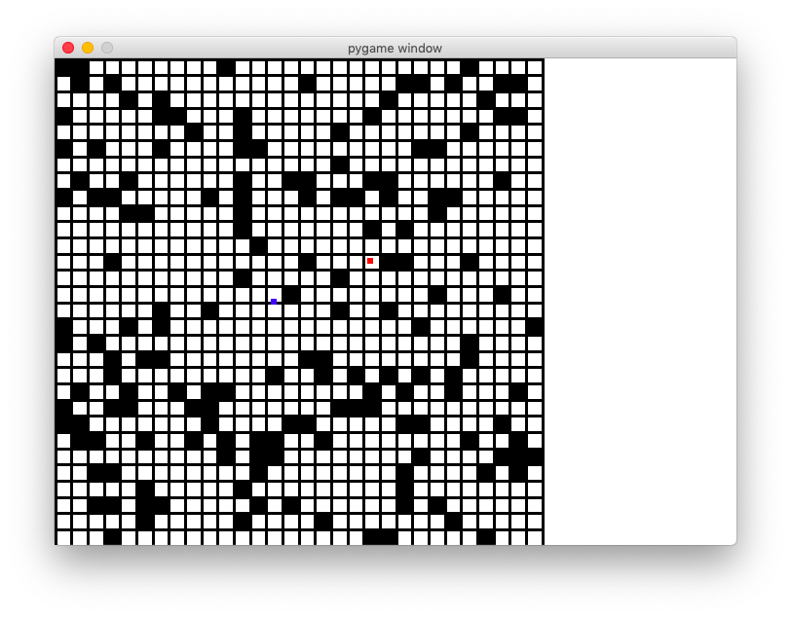

As one can see in the screen shot that the player (the blue square) moves off the centre of a tile, which may cause confusion to the user as to which square is the player currently in and thus worsen the experience of a user.

This problem is due to the definition of walls. Previously, walls are defined as long black lines, and the way the player moves is that it will move a fixed distance each time calculated from the separation between black lines, which might be rounded. When the player moves multiple times in one direction, those small errors start to accumulate and cause the player to move off the centre.

In order to resolve this issue, I need to go back to the place where I defined walls as long black lines. Instead of doing that, I defined each tile in the maze as an object itself. In this way, the coordinates to which the player is moving can be attributes embedded in each tile, and this ensures that the player will always stay in the centre no matter which tile it moves to.

Puzzle1.tile_list = [[Tile([0,0],[0,0])] * Puzzle1.maze_num **for** i **in** range(Puzzle1.maze_num)]

**for** i **in** range(Puzzle1.maze_num):  
 **for** j **in** range(Puzzle1.maze_num):  
 t = Tile((j * sideLength, i * sideLength), (sideLength, sideLength))  
 **if** Puzzle1.maze[i][j] == 1:  
 t.set_color(0)  
 Puzzle1.tile_list[i][j] = t

And this does prove to resolve the issue:

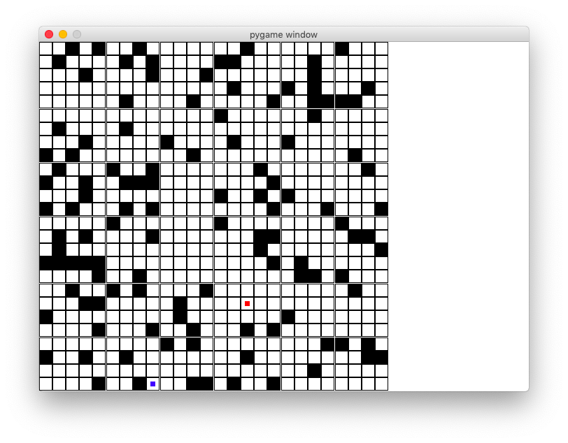

### Information display

Thirdly, the game information including instructions, progress, etc will be displayed, as required by requirement 3 and 6, in the area on the right-hand side of the game interface.

This will be implemented as a procedure and will be called in the main loop to keep it displayed on the screen.

**def** display_info(self):  
 *# game instruction* gameInstruction = []  
 gameInstruction.append(font.render(**"Game Instruction:"**, **True**, RED))  
 gameInstruction.append(font.render(**"Move the player to"**, **True**, BLACK))  
 gameInstruction.append(font.render(**"meet the princess"**, **True**, BLACK))  
 gameInstruction.append(font.render(**"in minimum number"**, **True**, BLACK))  
 gameInstruction.append(font.render(**"of moves"**, **True**, BLACK))  
 **for** i **in** range(len(gameInstruction)):  
 screen.blit(gameInstruction[i],[500+10,i*30])  
  
 *# game information* **if** self.my_player.get_cor()==Puzzle1.princess_cor **and** self.my_player.get_step()==self.solution:  
 screen.blit(font.render(**"You Win!"**, **True**, RED), [500 + 10, 200 + 10])  
 screen.blit(font.render(**"Congratulations"**,**True**,RED),[500+10,200+10+30])  
 **elif** self.my_player.get_cor()==Puzzle1.princess_cor:  
 screen.blit(font.render(**"Well done!"**, **True**, RED), [500 + 10, 200 + 10])  
 screen.blit(font.render(**"Try to do it with"**, **True**, RED), [500 + 10, 200 + 10 + 30])  
 screen.blit(font.render(**"fewer moves"**, **True**, RED), [500 + 10, 200 + 10 + 30*2])

#### testing

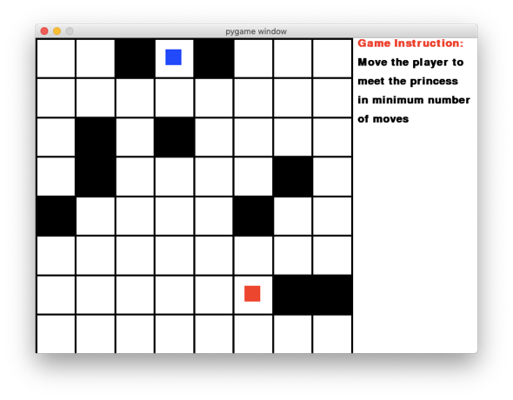A screen shot below illustrates the effect of adding instructions to the game.

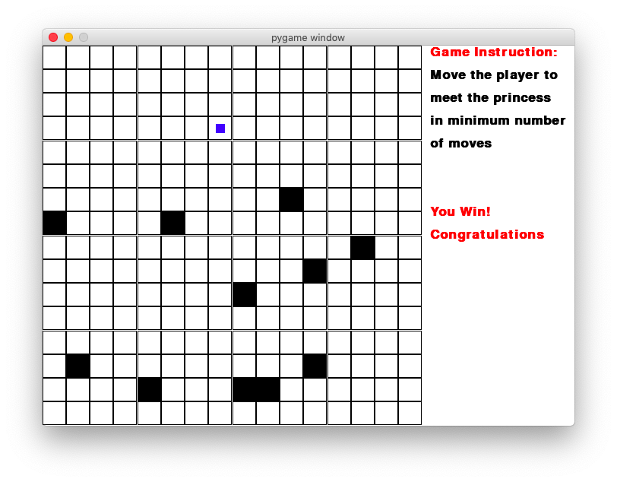Moreover, when the player finishes the game successfully, a piece of text indicating that the player has won the game will be displayed, which matches perfectly with the test criterion3.

### Button functions

According to requirement 12, essential functions should be made available to the user. Specifically, this is implemented as buttons in the game which provide different functionalities such as restart the game. Buttons are defined as a separate class, the methods of which provide the functionalities.

**class** Button(object):  
 **def** __init__(self, pos, size, color, word):  
 self.image = pg.Surface(size)  
 self.rect = self.image.get_rect(topleft=pos)  
 self.image.fill(color)  
 self.word = word  
 self.size = size  
  
 **def** is_over(self): *# returns whether the mouse is over the button, not necessarily a click* mouse_pos = pg.mouse.get_pos()  
 **return** self.rect.x < mouse_pos[0] < self.rect.x+self.size[0] **and** self.rect.y < mouse_pos[1] < \  
 self.rect.y+self.size[1]  
  
 **def** is_pressed(self): *# returns if the button is pressed* **return** self.is_over() **and** pg.mouse.get_pressed()[0] *# mouse needs to be over a certain button* **def** display(self): *# display word and the button on the screen* screen.blit(self.image, self.rect)  
 screen.blit(font.render(self.word, **True**, WHITE), [self.rect.x+5, self.rect.y+10])  
  
 **def** switch(self, color): *# switch the color of the button* self.image.fill(color)  
  
 **def** update(self):  
 **if** self.is_over():  
 self.switch(DARKGREY)  
 **else**:  
 self.switch(GREY)  
 self.display()

#### testing

Functions of buttons are also tested. Here is a glance of two buttons displayed on the screen. The retry button enables one to reset the position of the player without changing the maze while the restart button changes the setting of the maze so that users can try the puzzle with different sizes.



According to testing design No. 5 and 6, two of these buttons need to be working as expected. It is not easy to show how these two buttons work with screenshots, but they have been tested and they do indeed give the expected output.

### Solution in BFS

Finally, the correct solution of the puzzle will be calculated once the maze has been generated. BFS is used here as justified in the design. The algorithm used here to find the minimum number of moves is breath-first search, which is commonly used in finding an optimum solution. A queue is used to implement the search. The numerical answer will also be displayed in the game information section so that users know what is the optimum solution they are looking for.

**def** Bfs(startPpos, endPos):  
 **global** maze, nMazeNum  
 q = deque() *# every element in q is a list of three integers s[0]: row num, s[1]:column number, s[2]: number of steps* visited = [[0] * nMazeNum **for** i **in** range(nMazeNum)]  
 dir = [[0, 1, 0, -1], [1, 0, -1, 0]]  
 q.append([startPpos[0], startPpos[1], 0])  
 **while** q:  
 s = q.popleft()  
 print(**"element in queue"**, s)  
 **if** [s[0], s[1]] == endPos:  
 **return** s[2]  
 **for** i **in** range(4):  
 newR = s[0] + dir[0][i]  
 newC = s[1] + dir[1][i]  
 **if** newR < 0 **or** newR >= nMazeNum **or** newC < 0 **or** newC >= nMazeNum **or** maze[newR][newC] == 1 **or** visited[newR][  
 newC]:  
 **continue** q.append([newR, newC, s[2] + 1])  
 visited[newR][newC] = 1  
 **return** -1

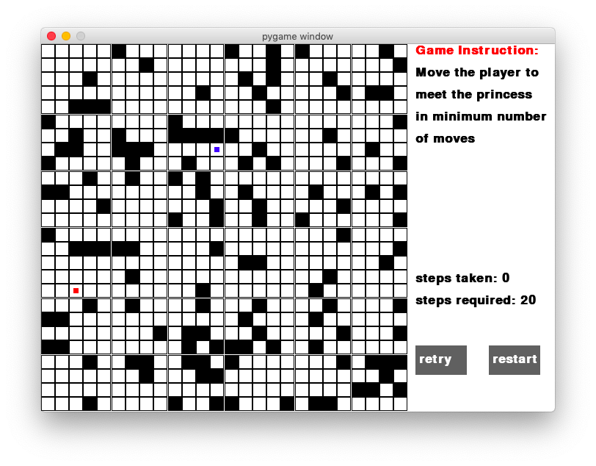

#### testing

However, by testing this, one can see that only the number of the optimum solution will be available to the user, but not how this number is found, which makes it harder for a user to trace through the actual shortest path. In order to reflect the requirement No.16 that the solution straightforward for the user to follow, a graphical solution will be displayed to the user via the solution button. And this is done by recording the actual path, in other words, update the previous node (named father node in the code) of each node while the algorithm is calculating the solution.

**def** get_solution(self):  
 self.solution = -1  
 self.solution_list = []  
 q = []  
 qHead=0  
 qTail=0  
 *# every element in q is a list of three integers s[0]: row num, s[1]:column number;  
 # s[2]: number of steps, s[3]: father* visited = [[0] * Puzzle1.maze_num **for** i **in** range(Puzzle1.maze_num)]  
 dir = [[0, 1, 0, -1], [1, 0, -1, 0]]  
 startPos = self.my_player.get_cor()  
 endPos = Puzzle1.princess_cor  
 q.append([startPos[0], startPos[1], 0, -1])  
 qTail += 1  
 *# bfs implementation* **while** qHead!=qTail:  
 s = q[qHead]  
 **if** [s[0], s[1]] == endPos:  
 self.solution=s[2]  
 father = qHead  
 **while True**:  
 self.solution_list.append([q[father][0],q[father][1]])  
 father=q[father][3]  
 **if** father==-1:  
 **break** self.solution_list.reverse()  
 **break  
 for** i **in** range(4):  
 new_r = s[0] + dir[0][i]  
 new_c = s[1] + dir[1][i]  
 **if** new_r < 0 **or** new_r >= Puzzle1.maze_num **or** new_c < 0 **or** new_c >= Puzzle1.maze_num **or** Puzzle1.maze[new_r][  
 new_c] == 1 **or** visited[new_r][new_c]:  
 **continue** q.append([new_r, new_c, s[2] + 1,qHead])  
 qTail+=1  
 visited[new_r][new_c] = 1  
 qHead += 1

And this is the how the path is displayed when the display solution button is held. The green path is one if the correct paths that will give the steps required.

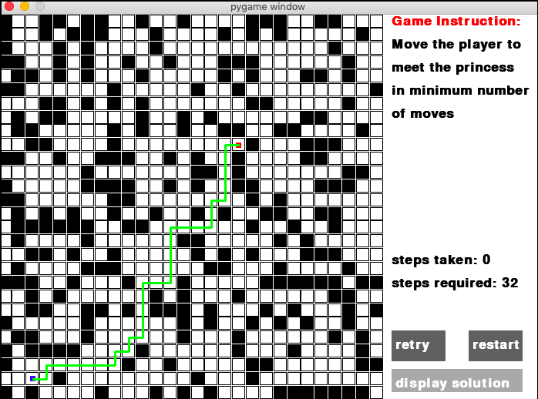

### Review

Until now the puzzle1 has been completed with 5 steps. And this stage is broken down into these steps to reflect the following requirements:

* Player movement
* All information required is displayed
* Game running correctly and logically
* Problem illustration as straightforward as possible
* Essential functions are implemented and available to the user
* Solutions are straightforward for players to follow

There are also some changes and improvements that will be included in the next two puzzles, in order to improve the game logic, user experience, etc.

1. Each puzzle will be defined as a class and all of its behaviours, such as finding the solution, displaying game instructions, will be implemented as its methods. There are also some attributes that will be included such as a list of tiles in the first puzzle. Furthermore, in order to make the relation between different puzzles clear, each Puzzle class will inherit a same superclass that acts like a virtual class.
2. Whilst developing the first puzzle, a problem that the player can move off the centre inspired me to define tile as a class. In the next puzzle that I am going to develop, which is to do with graph theory, where nodes will be used, the node will be defined as a class as well. This proves to quite an efficient way based on using tile as a class in the first puzzle.
3. Displaying the solution graphically in addition to the numerical answer to the puzzle could give the user more insight into how the problem can be solved and will be used in the next two puzzles as well.
4. Buttons will turn light grey when the mouse is over, which is naturally how a button behaves. This can give the user better experience while solving the puzzle, and will be used in future development as well.

## Stage2: puzzle2

Again, the second puzzle is also divided into several steps in the design section. As each puzzle has a lot of features in common, steps that are designed to complete the stage will also have some similarities. Again, there is not a particular order in which different steps need to be completed, but I would follow the order in which the problem is broken down.

### Graph generation

Graph, player and the target will need to be generated first so that further operations on them are possible. By the review from stage1, I have decided to implement puzzle2 as a class and it will inherit the super class Puzzle, just like the Puzzle1 class does. It is natural, after defining it as a class, to include the graph generation procedure as a method of class Puzzle2. The initialise method also overrides the method in the class Puzzle, so that polymorphism can be used to make the code more flexible. It is also part of the requirement that the idea of OO needs to be used in the program so that it can be easily managed and updated in the future.

An adjacency list will be used to store the graph as the number of edges is randomly generated and therefore the graph could be sparse, in which case an adjacency can be useful. The position of the player and the target will both be random, similar to how it is done in the first puzzle.

The following code is used to generate the graph:

**def** initialise(self):  
 Puzzle2.node_num=random.randrange(3, 30)  
 *# generate the position of every node* num = int(math.sqrt(Puzzle2.node_num)) + 1  
 sep=500/num  
 i = 0  
 j = 0  
 minR=500  
 **for** k **in** range(Puzzle2.node_num):  
 start_x=int((j+0.1)*sep) *# leave some blank space* end_x=int((j+0.9)*sep)  
 start_y=int((i+0.1)*sep)  
 end_y=int((i+0.9)*sep)  
 circlePos=[random.randint(int(start_x+sep*0.2),int(end_x-sep*0.2)),random.randint(int(start_y+sep*0.2),int(end_y-sep*0.2))]  
 *# make sure the node is not too small* radius=min(circlePos[0]-start_x,end_x-circlePos[0],circlePos[1]-start_y,end_y-circlePos[1])  
 minR=min(radius,minR)  
 Puzzle2.node_list.append(Node(circlePos,radius,k,DARKGREY))  
 j+=1  
 **if** j == num:  
 i += 1  
 j %= num  
  
 *# generate the graph in a adjacency list* Puzzle2.graph = [[] **for** i **in** range(Puzzle2.node_num)]  
 **for** i **in** range(Puzzle2.node_num):  
 used = [0] * (Puzzle2.node_num + 1)  
 used[i]=1  
 outDegree = random.randrange(1, int(Puzzle2.node_num * 0.8))  
 j=0  
 **while** j < outDegree:  
 n = random.randrange(0, Puzzle2.node_num)  
 **if** used[n]:  
 **continue** used[n]=1  
 j+=1  
 w = random.randrange(1, 100)  
 node=Puzzle2.node_list[n]  
 node.set_weight(w)  
 Puzzle2.graph[i].append(node)  
  
 *# initialise the player* n1=Puzzle2.node_list[random.randrange(0, Puzzle2.node_num)]  
 self.my_player=Player2(n1.get_centre(),[minR,minR],BLUE, n1.num)  
 Puzzle2.visited_node.append(n1)  
 all_sprites_group.add(self.my_player)  
 **while True**:  
 n2=Puzzle2.node_list[random.randrange(0, Puzzle2.node_num)]  
 **if** n2.num!=n1.num:  
 princess=NPC(n2.get_centre(),[n2.get_size(),n2.get_size()],RED, n2.num)  
 all_sprites_group.add(princess)  
 Puzzle2.princess_cor=n2.num  
 **break**

Up till now the graph has been generated, but it will not be visualised until the next step, and therefore the test will be carried out in the next step, edges and nodes display.

### Edges and nodes display

The unique part of this puzzle2 is that involves essential graph element, i.e. edges and nodes. Therefore, it is important to draw these edges and nodes properly on the screen so that a user can not only get a better understanding of what a graph looks like, but also able to play the game easily. Nodes are drawn with the following method.

**def** draw_nodes():  
 **for** i **in** range(Puzzle2.node_num):  
 n=Puzzle2.node_list[i]  
 pg.draw.circle(screen,n.get_color(),n.get_centre(),n.get_size())

#### testing

Edges are, by definition, connections between different nodes. So, one would naturally draw a line between the centres of two nodes. Whilst it is easy to draw edges by hand when there is a small number of them, problems arise when the number of edges increase when one tries to sketch all of them, below is what it would look like.

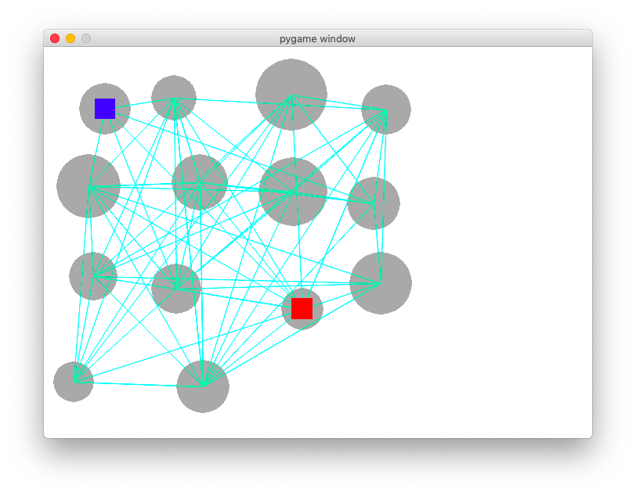

When tested, it is obvious that edges are too close together, and it is too hard for the player to figure which edges are connected to one node, and this also does not meet the requirement that this game should provide good user experience and problem illustration as people can get confused as to what this graph is about. Therefore, in order to solve this problem, I tried to display edges only when the player is in that node, or when the mouse is placed over a particular node. This can also improve the usability feature of the game.

**def** draw_edges(self): *# draw the edge if the player is on the node or if the mouse is over* **for** n **in** Puzzle2.node_list:  
 **if** n.is_mouse_over():  
 self.draw_edges_from_node(n)  
  
 n=Puzzle2.node_list[self.my_player.get_cor()]  
 self.draw_edges_from_node(n)

Again, in order to illustrate the problem clearly, it is also important to consider carefully how the weights of each edge will be displayed, though this can be easily done by hand when the number of edges is small. Considering the overlapping between edges, I have decided to display the weight of each edge at the middle point of each edge so that when a user can always refer to the middle point when he/she is looking for the weight of the edge.

This is the final display of edges with weights on them.

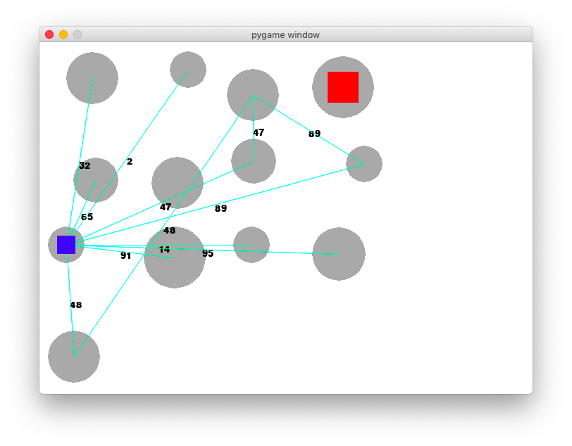

This game is tested by playing it again and another problem is found. Users might find it hard to remember the path they have already taken, in other words, which nodes they have already visited, especially there is a long way from the source to the destination. It might be useful to highlight the path that has been taken by the player so that it is easier for the user to make further decisions.



It can be seen that the path taken by the blue square is highlighted in light green and this makes it easy for the user to refer to what path they have taken. This is also a reflection of requirement 10 that the game can run smoothly and provides good user experience.

The game now gives expected output and passes the test 10, 12,14 and 21.

### Information display

Similar to puzzle1, some information of the game needs to be displayed to help the player understand the game, which is, again, required by the requirement 3 and 6. This includes: game instructions, the correct answer to the puzzle, the length of the path that has already been taken, whether the game is finished, etc. The main method display_info also overrides the method in the parent class Puzzle.

**def** display_info(self): *# display necessary information of the game, such as life, time steps  
 # game instruction* gameInstruction = []  
 gameInstruction.append(font.render(**"Game Instruction:"**, **True**, RED))  
 gameInstruction.append(font.render(**"Click a node to move"**, **True**, BLACK))  
 gameInstruction.append(font.render(**"the player to meet"**, **True**, BLACK))  
 gameInstruction.append(font.render(**"the princess by the"**, **True**, BLACK))  
 gameInstruction.append(font.render(**"shortest path"**, **True**, BLACK))  
 **for** i **in** range(len(gameInstruction)):  
 screen.blit(gameInstruction[i], [500 + 10, i * 30])  
  
 *# game information* **if** self.my_player.get_cor() == Puzzle2.princess_cor **and** self.my_player.get_path() == self.solution:  
 screen.blit(font.render(**"You Win!"**, **True**, RED), [screenSize[1] + 10, 200 + 10])  
 screen.blit(font.render(**"Congratulations"**, **True**, RED), [screenSize[1] + 10, 200 + 10 + 30])  
 **elif** self.my_player.get_cor() == Puzzle2.princess_cor:  
 screen.blit(font.render(**"Well done!"**, **True**, RED), [screenSize[1] + 10, 200 + 10])  
 screen.blit(font.render(**"Try to do it with"**, **True**, RED), [screenSize[1] + 10, 200 + 10 + 20])  
 screen.blit(font.render(**"fewer moves"**, **True**, RED), [screenSize[1] + 10, 200 + 10 + 20 * 2])  
  
 screen.blit(font.render(**"path length: "** + str(self.my_player.get_path()), **True**, BLACK), [screenSize[1] + 10, 275 + 10])  
 screen.blit(font.render(**"shortest path: "** + str(self.solution), **True**, BLACK), [screenSize[1] + 10, 275 + 10 + 30])

#### testing

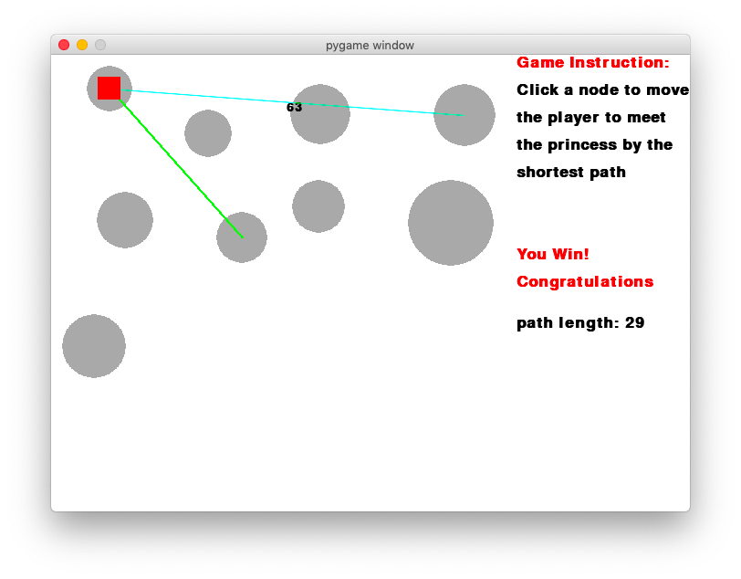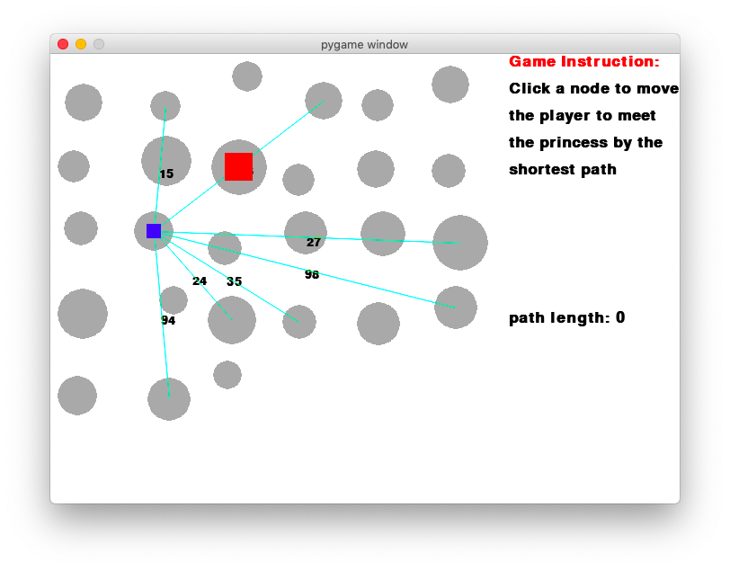The test shows that the game matches the expectation of test No. 15.

### Button functions

As with puzzle1, puzzle 2 will also have three basic buttons available, which are retry, restart and display solution. The implementation of these buttons is similar to the ones in the previous puzzle, and is not included here.



#### testing

However, while playing the game, it is really easy for a user to make a wrong move and there is currently no way for the player to undo the movement. Furthermore, according to the specification, it is also essential for the game to have a good user experience. It would be really awkward if the user had to start the game again every time he/she makes a wrong move. Therefore, it might be worthwhile to include a back button that allows the user to move one step back. In addition, a button that can display all edges will also be included in case users want to have a look at the overall structure of the graph.

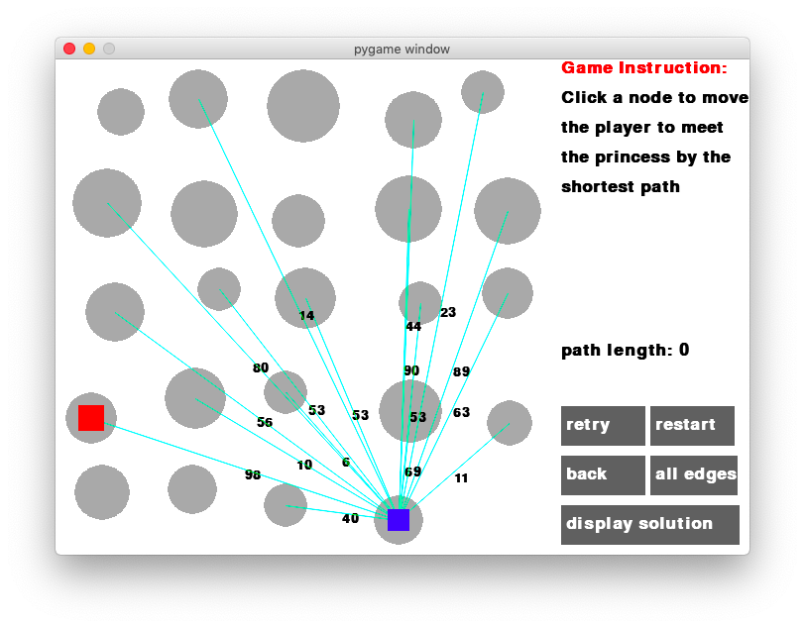

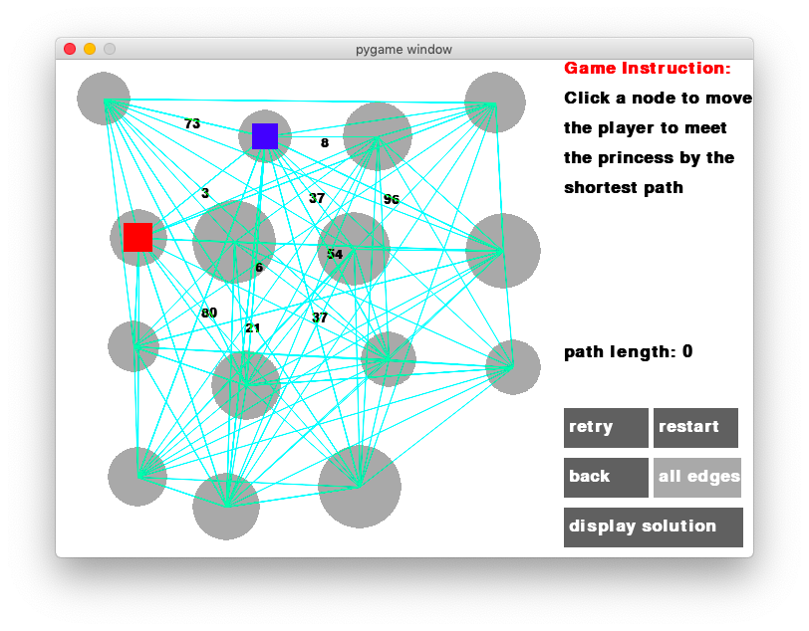

All the buttons in this puzzle are now working properly and therefore the tests 16-20 are passes. In addition, two extra buttons back, and all edges are added to enable better user experience and meets the requirement 12.

### Solution in Dijkstra’s

By the review of puzzle1, the solution to a puzzle should not only give a numerical answer, but also display it graphically, so that the user can find it easier to trace through the problem rather than struggling with figuring out how the answer is obtained. The answer is found using a famous path-finding algorithm – Dijkstra’s. This choice has also been justified in the pseudocode section of the design.

**def** get_solution(self): *# find the optimum solution of a problem* self.solution_list=[]  
 visited=[0]*Puzzle2.node_num  
 dist=[INF]*Puzzle2.node_num  
 prev=[0]*Puzzle2.node_num  
 pq=queue.PriorityQueue()  
 nd=copy.deepcopy(Puzzle2.node_list[self.my_player.get_cor()])  
 nd.set_weight(0)  
 pq.put(nd)  
 prev[nd.num]=-1  
 dist[nd.num]=0  
 **while not** pq.empty():  
 nd=pq.get()  
 **if** visited[nd.num]:  
 **continue  
 if** nd.num == Puzzle2.princess_cor:  
 self.solution=dist[nd.num]  
 father=nd.num  
 **while True**:  
 self.solution_list.append(father)  
 **if** prev[father] == -1:  
 **break** father = prev[father]  
 self.solution_list.reverse()  
 **break** visited[nd.num]=1  
 **for** n **in** Puzzle2.graph[nd.num]:  
 **if** visited[n.num]:  
 **continue  
 if** dist[n.num] > dist[nd.num] + n.weight:  
 dist[n.num] = dist[nd.num] + n.weight  
 prev[n.num] = nd.num  
 pq.put(n)

#### testing

Again, when the display solution button is pressed, the graphical solution will be displayed on screen in red lines as follows:

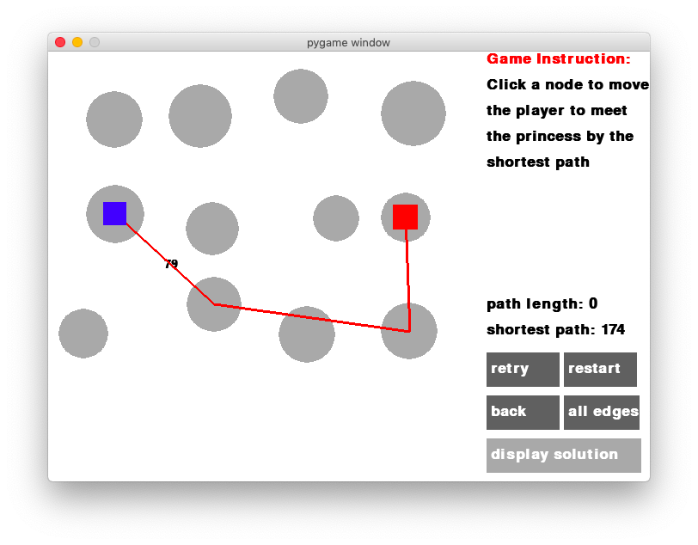

This has adopted the improvement from the review of stage1 and matches well with the algorithm test of this puzzle.

### Review

Similar to puzzle1, puzzle 2 has been completed with 5 steps, and here are the requirements that have been met with the development of this stage:

* Clear instruction on how to play the game
* All information required is displayed
* Player movement
* Essential functions are implemented and available to the user
* Solutions are straightforward for players to follow

Following on the review from stage 1, some good practice is used as an improvement to stage 1 and to keep the code logically consistent and easy to maintain, which is also part of the requirements that code needs to be as elegant as possible. Improvements include defining puzzle as a super class and each individual puzzle will inherit from the general one; defining game elements as classes, which in the case of puzzle 2 are nodes, helps maintain their positions and other attributes. Problems such as player moving off the centre can be easily avoided with this technique, and this is also to reflect the requirement that the idea of OOP is used properly throughout the game.

There are also some further improvements that can be made in future development, based on the development of this stage.

1. Button functions need to be designed according to the characteristics of the current puzzle. For example, in puzzle2, the game would have been much more difficult for the user to play without the back button as the user would need to make sure that every single movement is correct, or they would have to play the game from the beginning again. Including the back function is therefore a natural thing to do, given the fact that this is game is aimed primarily at learners of some algorithms;
2. It is important that the graphical display of the game on the screen includes all necessary information. This idea is based on the edge display and path highlight in stage2. Again, without highlighting path that have been taken and display edges in a proper way, this game is much harder to play in terms of its usability rather than difficulty. Therefore, it is vital to consider what to display in the development of next stage so as to make the game as straightforward as possible.

## Stage3: puzzle3

This puzzle is to simulate a famous NP problem in computer science – knapsack problem. Similar to previous two puzzles, the third puzzle is divided into five steps. Here is how it is divided.

### Bag and items generation

Before the game can start, it is essential to illustrate the problem. Some elements need to be generated and displayed on the screen, i.e. a bag to hold elements (represented by a red box) with particular volume and weight and items of different weights and volume (represented by black boxes). Number of items will be again, generated randomly. Corresponding codes are in the initialise method of Puzzle3.

**def** initialise(self):  
 Puzzle3.item_num=random.randrange(4, 30)  
 self.my_player = Bag([250, 65], [100, 70], RED, random.randint(10, 100))  
 all_sprites_group.add(self.my_player)  
 num_x = int(math.sqrt(10 / 7 * Puzzle3.item_num)) + 1  
 num_y = int(math.sqrt(7 / 10 * Puzzle3.item_num)) + 1  
 sep_x = 500/num_x  
 sep_y = 350/num_y  
 i = 0  
 j = 0  
 **for** k **in** range(Puzzle3.item_num):  
 start_x = int((j+0.3)*sep_x)  
 end_x = int((j+0.7)*sep_x)  
 start_y = 150+int((i + 0.3) * sep_y)  
 end_y = 150 + int((i + 0.7) * sep_y)  
 item_pos = [start_x,start_y]  
 size = [end_x-start_x,end_y-start_y]  
 v = random.randrange(5,50)  
 w = random.randrange(1,100)  
 item = Item(item_pos,size,BLACK,v,w)  
 Puzzle3.item_list.append(item)  
 all_sprites_group.add(item)  
 j += 1  
 **if** j == num_x:  
 i += 1  
 j %= num_x



Next, it is essential to display weights and volume of every element displayed on the screen so that the player can see the progress of the game as well as help them decide which items to choose.

**def** display_weight_and_volume(self):  
 p = self.my_player.get_pos()  
 s = self.my_player.get_size()  
 pos = [p[0], p[1]+s[1]]  
 font = pg.font.SysFont(**'Calibri'**, 25, **True**, **False**)  
 screen.blit(font.render(**"V = "**+str(self.my_player.get_volume()), **True**, BLACK), pos)  
 screen.blit(font.render(**"W = "**+str(self.my_player.get_weight()),**True**,BLACK), [pos[0],pos[1]+20])  
  
 **for** item **in** Puzzle3.item_list:  
 p = item.get_pos()  
 s = item.get_size()  
 pos = [p[0], p[1]+s[1]+5]  
 font = pg.font.SysFont(**'Calibri'**, int(s[0]*0.7), **True**, **False**)  
 screen.blit(font.render(**"V="** + str(item.get_volume()), **True**, BLUE), pos)  
 screen.blit(font.render(**"W="** + str(item.get_weight()), **True**, BLUE), [pos[0], pos[1] + s[0]*0.5])

#### testing

The picture below shows that the bag and items are properly displayed, with volume and weight underneath, which is what is expected according to the testing design 23 and 24.

So far, core elements of this game have been generated, and I can move on to the next step.

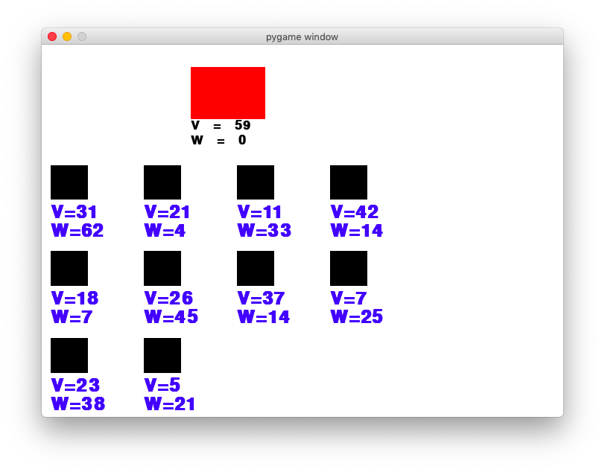

### Click to select and deselect

The fundamental move one can make in the game is to choose, therefore, it is important to give the user the ability to choose items in some way. Here I decided to let the user click to choose items that they want as this is the easiest way in terms of making choices as far as I am concerned. In order to show the user that he/she has chosen some items, those that have been clicked will be highlighted in green. This will be implemented as a method of the class Puzzle 3 and will be run constantly in the main loop as well.

**def** item_highlight(self):  
 **for** item **in** Puzzle3.item_list:  
 added = item.clicked()  
 **if** item.selected:  
 item.highlight(GREEN)  
 **if** added == 1:  
 self.my_player.weight += item.get_weight()  
 self.my_player.volume -= item.get_volume()  
 **elif** added == -1:  
 self.my_player.weight -= item.get_weight()  
 self.my_player.volume += item.get_volume()

#### testing



Up to this stage, the user is free to make choices, however, it is very likely that the user wants to undo his/her decision as sometimes a wrong decision could be made but only noticed later on. Similar to the second puzzle, if the user is not able to deselect an item, which means he/she will need to retry the game from the beginning, it can be a serious drawback of the game in terms of its usability. Therefore, both selecting and deselecting are included in the methods of items.

**def** clicked(self):  
 **if** self.mouse_pressed() == 1 **and not** self.selected:  
 self.selected = **True  
 return** 1  
 **elif** self.mouse_pressed() == 2 **and** self.selected:  
 self.selected = **False  
 return** -1  
 **else**:  
 **return** 0

With this implementation, the user can now left click to select items and right click to deselect, which are two of the basic functions of this game, and now it has met two of the criteria set in the testing design regrading selecting and deselecting.

### Information display

At this phase, some game information needs to be displayed, these include game instructions, the outcome of the game, etc. The largest weight the player should be aiming for will also be displayed, the numerical value of which will be calculated at the final step. Just like previous two stages, the code of this part will be implemented as a method of class Puzzle3.

**def** display_info(self): *# display necessary information of the game, such as life, time steps  
 # game instruction* gameInstruction = []  
 gameInstruction.append(font.render(**"Game Instruction:"**, **True**, RED))  
 gameInstruction.append(font.render(**"Select items that "**, **True**, BLACK))  
 gameInstruction.append(font.render(**"will have maximum"**, **True**, BLACK))  
 gameInstruction.append(font.render(**"overall weight with a"**, **True**, BLACK))  
 gameInstruction.append(font.render(**"given volume"**, **True**, BLACK))  
 **for** i **in** range(len(gameInstruction)):  
 screen.blit(gameInstruction[i], [500 + 10, i * 30])  
  
 *# game information* **if** self.my_player.get_weight() == self.solution:  
 screen.blit(font.render(**"You Win!"**, **True**, RED), [500 + 10, 200 + 10])  
 screen.blit(font.render(**"Congratulations"**, **True**, RED), [500 + 10, 200 + 10 + 30])  
  
 **if** self.my_player.get_volume() < 0:  
 screen.blit(font.render(**"Whoops! Right lick "**, **True**, RED), [500 + 10, 200 + 10])  
 screen.blit(font.render(**"selected item again"**, **True**, RED), [500 + 10, 200 + 10 + 20])  
 screen.blit(font.render(**"to deselect it"**, **True**, RED), [500 + 10, 200 + 10 + 20 + 20])  
  
 screen.blit(font.render(**"Largest weight: "** + str(self.solution), **True**, BLACK), [500 + 10, 280])

#### testing

The game is run and tested, one can see the effect above as expected and hence it has successfully passed the test No. 25.

### Button functions

Button is a common feature to all three puzzles is button, in the case of puzzle3, there is not any particular important functionalities to be implemented as buttons, as one of the most important functions is achieved by right clicking an item. Therefore, buttons in this puzzle will be the same as puzzle1, so the code is not included here.

The function of display solution button will, however, be dependent on the solution to this puzzle and will therefore not work at this step. I will finish the function of this button when I have finished the next step, which is to calculate the answer using dynamic programming.

### Solution in DP

Finally, the solution of the puzzle will need to be calculated and displayed in the game information section on the right-hand side as shown at the information display stage. Here dynamic programming is used to calculate the answer as it is both quick and easy to implement.

Furthermore, according to the review of stages one and two, not only the numerical answer but also the graphical solution will need to be displayed on the screen to help users understand how the algorithm works, which is also a requirement that solutions are straightforward for players to follow. Here, an additional array is used to store items that are selected so that they can be displayed on the screen.

All of these codes are included as a method of the class Puzzle three.

**def** get_solution(self): *# find the optimum solution of a problem* w = [0]*(Puzzle3.item_num + 1)  
 v = [0]*(Puzzle3.item_num + 1)  
 **for** i **in** range(1, Puzzle3.item_num + 1):  
 w[i] = Puzzle3.item_list[i-1].get_weight() *# i-1 is because index starts from 0 in the item_list* v[i] = Puzzle3.item_list[i-1].get_volume()  
  
 dp = [[0] * (self.my_player.volume+1) **for** i **in** range(Puzzle3.item_num + 1)]  
 choices = [[[]] * (self.my_player.volume + 1) **for** i **in** range(Puzzle3.item_num + 1)]  
 *# store how items are selected for dp[i][j]* **for** i **in** range(1, Puzzle3.item_num + 1):  
 **for** j **in** range(1,self.my_player.get_volume()+1):  
 dp[i][j] = dp[i-1][j]  
 choices[i][j] = choices[i-1][j]  
 **if** j >= v[i] **and** dp[i-1][j-v[i]]+w[i] > dp[i-1][j]:  
 dp[i][j] = dp[i-1][j-v[i]]+w[i]  
 choices[i][j] = choices[i-1][j-v[i]] + [i]  
  
 self.solution = dp[Puzzle3.item_num][self.my_player.get_volume()]  
 self. solution_list = choices[Puzzle3.item_num][self.my_player.get_volume()]

#### testing

Once the display solution button is pressed, the solution will be displayed on the screen, with items need to be selected highlighted in red. This test does pass the 19th and 33rd test as listed above.



### Review

During this stage, the following criteria have been met:

* Clear instruction on how to play the game
* All information required is displayed
* Essential functions are implemented and available to the user
* Solutions are straightforward for players to follow

It has also been tested against the testing design, all eleven tests designed for this puzzle are now, with some modifications and iterative development, passed.

The main part of this game has now been completed with three stages, in other words, all the key elements are now working, leaving only one final thing to be completed, which is the puzzle selection user interface, which is also what the final stage will be handling with.

## Final stage: puzzle selection

Comparing with other three stages, this stage is relatively straightforward and does not need much careful break-down. The basic idea is that there will be three buttons displayed, each leading to a specific puzzle. Once one of the buttons is pressed, the program will respond and go to the corresponding puzzle. The puzzle selection will also be defined as a class which inherits the Puzzle class.

**class** PuzzleSelection(Puzzle):  
 **def** __init__(self):  
 super().__init__()  
 self.my_player = Element([0, 0], [0, 0], BLACK)  
 self.puzzle1 = Button([50, 50], [180, 50], GREY, **"Save the princess"**)  
 self.button_list.append(self.puzzle1)  
 self.puzzle2 = Button([50, 200], [180, 50], GREY, **"Shortest path"**)  
 self.button_list.append(self.puzzle2)  
 self.puzzle3 = Button([50, 350], [180, 50], GREY, **"Knapsack problem"**)  
 self.button_list.append(self.puzzle3)  
 **def** display_info(self):  
 font1 = pg.font.SysFont(**'Calibri'**, 35, **True**, **False**)  
 screen.blit(font1.render(**"Welcome"**, **True**, BLUE),[280,10])  
 screen.blit(font.render(**"More challenges"**, **True**, BLACK),[360,350])  
 screen.blit(font.render(**"coming soon..."**,**True**,BLACK),[360,380])  
 **def** button_function(self):  
 **global** curPuzzle  
 **if** self.puzzle1.is_pressed():  
 curPuzzle = Puzzle1()  
 curPuzzle.pre_update()  
 **elif** self.puzzle2.is_pressed():  
 curPuzzle = Puzzle2()  
 curPuzzle.pre_update()  
 **elif** self.puzzle3.is_pressed():  
 curPuzzle = Puzzle3()  
 curPuzzle.pre_update()  
  
 **for** b **in** self.button_list:  
 b.update()  
  
 **def** update(self):  
 self.button_function()  
 self.display_info()

#### testing

Here is how it looks when the program run and tested.



### Review

This is the last stage of the development cycle and all functions have now been completed. All of the following success criteria are satisfied:

* Clear instruction on how to play the game
* Player movement
* All information required is displayed
* Game running correctly and logically
* Problem illustration as straightforward as possible
* Essential functions are implemented and available to the user
* The user needs to think strategically in order to pass the game
* Principles behind games are logically strict
* Puzzles are chosen based on how classic and how often they are used to solve problems
* Idea of OO is used properly throughout
* Puzzles are carefully selected so that they are neither too obscure nor too basic
* Puzzles are designed to deepen the understanding of algorithms rather than broaden the knowledge

# Evaluation

Now it is time to go back and review the final product and compare it with the requirements produced at the analysis stage. As the requirements are divided into three categories, I will evaluate my program in this order.

## Success criteria (must)

All key requirements labelled with a must are the success criteria of this game and the almost all of them are met, and the evidence of which is provided by carrying out some post development testing.

### Clear instruction on how to play the game

This is to enable the user to start the game smoothly and it is also essential that the user is clear about how to play the game, otherwise it is pointless to develop the game.

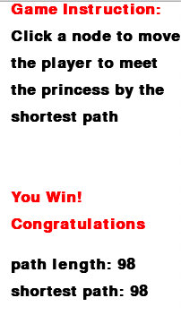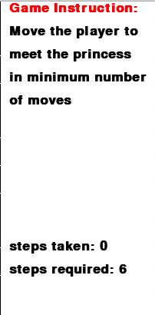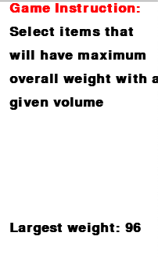

As one can see there is a dedicated area in each of the puzzle to give the user game instructions and other essential information, such as the outcome of the game, so that the user can have a decent understanding of the game after a few trials. This criterion has been met.

### Player movement

This is another key function of the game – the ability to move. A better and more general way of describing this requirement is that the game can give necessary response to the user input. A series of screenshots below show how this is achieved in each of the puzzle.

Initial position and the value is zero.

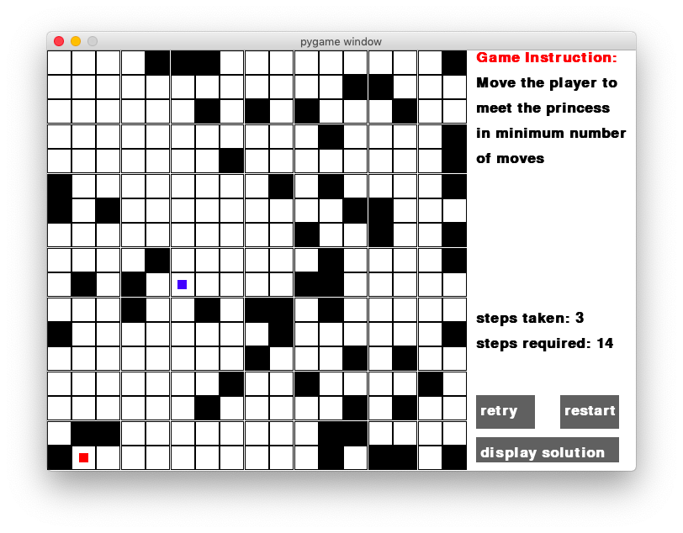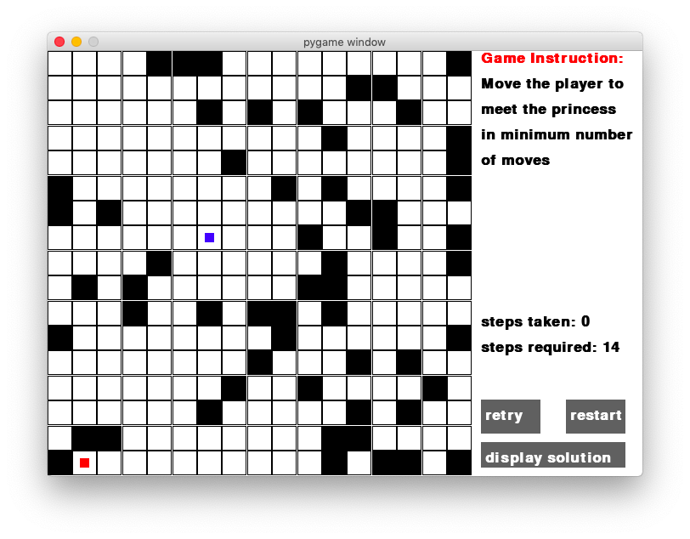

The player has moved three steps and the value becomes three.

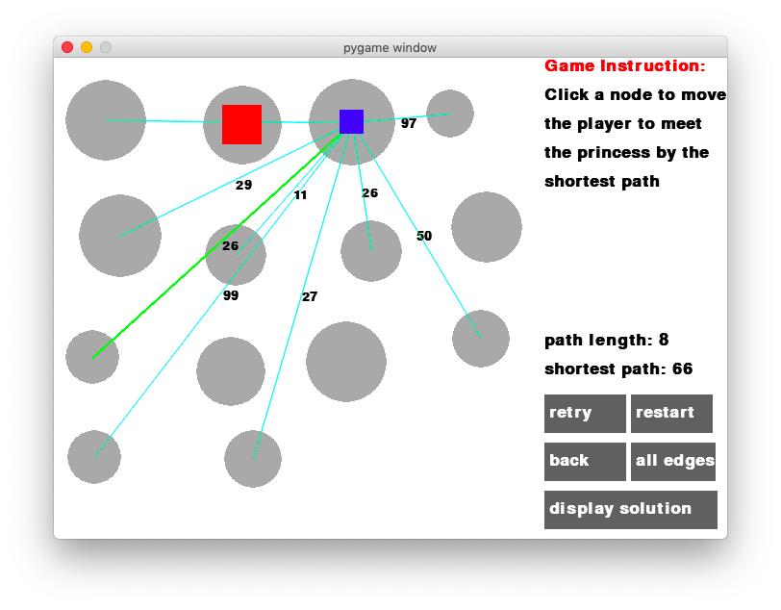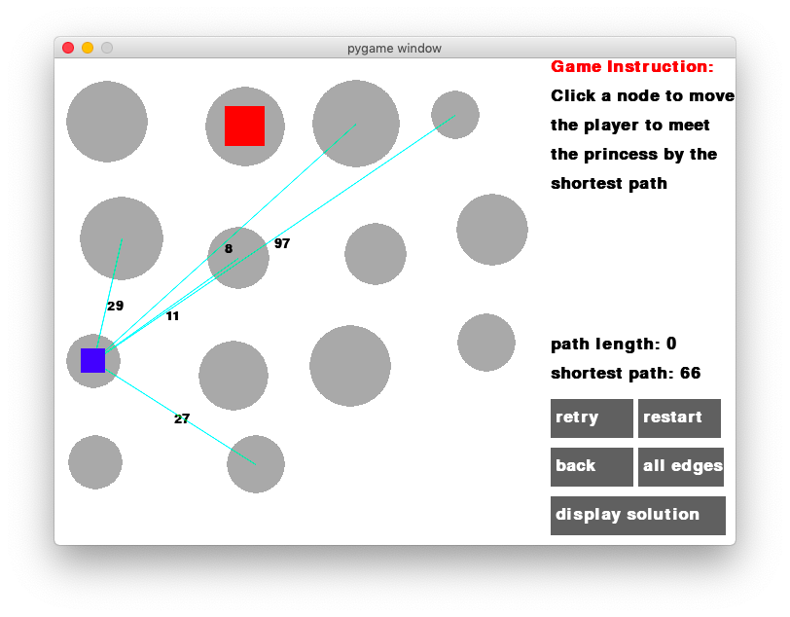

Now the player is in a new node and the path length has been updated.

The player is now at its initial position, and suppose that it will follow the edge of weight 8.

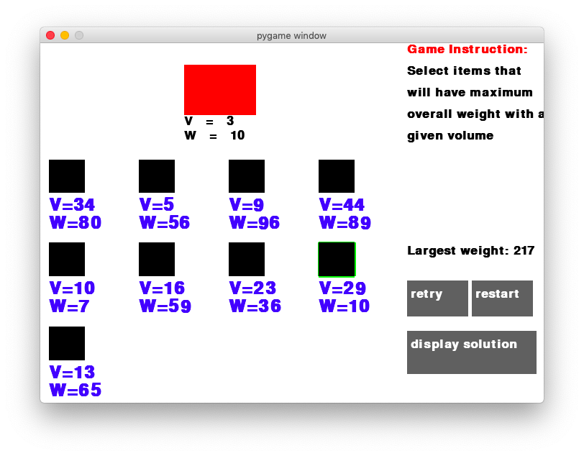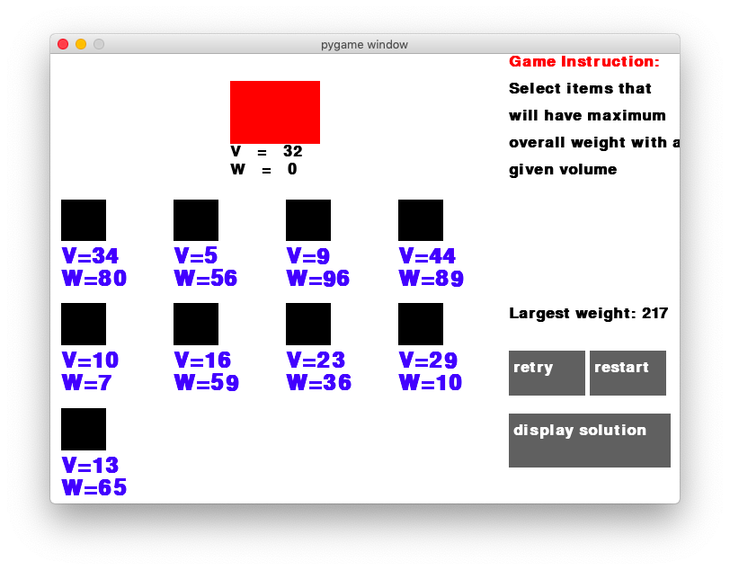

This item is now selected and the volume and the weight of the bag are changed.

The weight of the bag is zero at start.

In all three puzzles, this criterion has been achieved – moving with arrow keys in the first puzzle and click to move and select in the second and third puzzle. In other words, all three puzzles will give response to the user inputs as expected and therefore this requirement is met.

### All information required is displayed

Similar to the first requirement, this requirement is met by the existence of game information of each of the puzzle. For example, in the third puzzle:

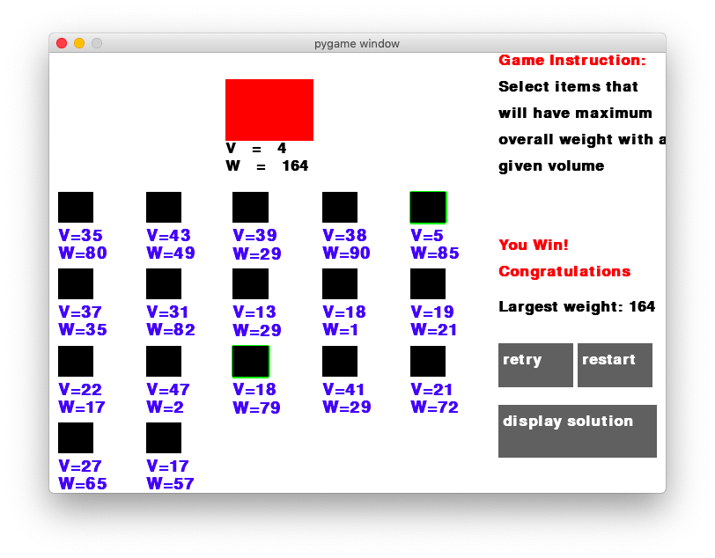

Game information section in the third puzzle.

### Game running correctly and logically

It is important to make sure that the logic of the game is correct and some simple tests are carried out on each of the puzzle.

For the first puzzle, the movement of the player is essential, therefore I did the test to see what happens if one continues to move the player when it is next to the edge of the map, it turns out that the player will not move as required.

For example, in the screen below, the player is at the upper boundary of the maze, and it will not move any further even if the up-arrow key is pressed.

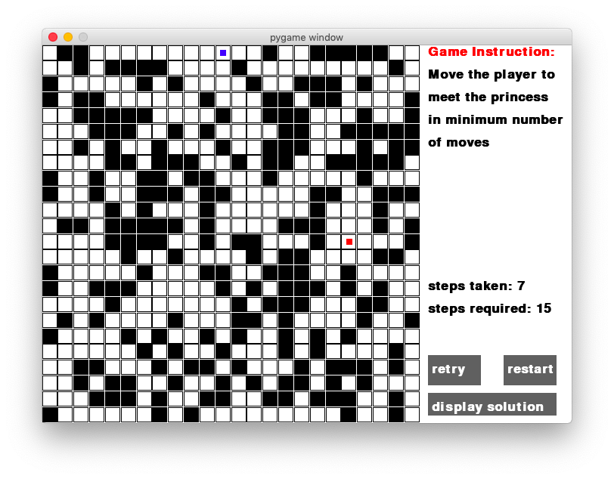

The second puzzle involves moving across different nodes, a simple test would be to see if the player will move between two unconnected nodes by clicking a node that is not connected to the one that the player is currently on. And the result is also as expected.

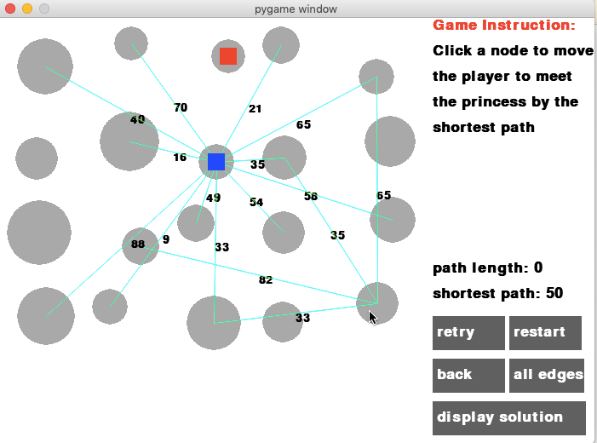

When clicking on a node that is not connected, the player will not move.

The last puzzle is about selection of items, so I tried to select same items multiple times and the expected outcome is that the weight of the bag stays the same and it turns out to be so.

As one can see that clicking on the same item does not make a difference to the volume and weight of the bag.

Clicking on the same item multiple times does not make a difference.

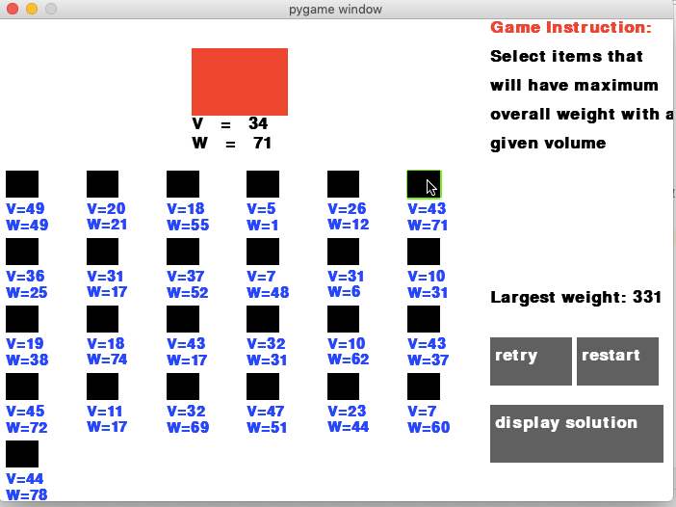

It is therefore reasonable to say that the game can run correctly and logically by the tests that have been done so far.

### Puzzles are chosen based on how classic and how often they are used to solve problems

It is not easy to tell how classic an algorithm is but solutions three puzzles, which are Breath-first search, Dijkstra’s and dynamic programming are all widely used and considered relatively classic.

### Idea of OO is used properly throughout

This requirement can be tested by looking at the code. Furthermore, throughout the development stages, there has been some reviews on the use of classes to handle the relationship between puzzles. For example, although each puzzle seems to be very independent of each other, they are all defined as a class and all inherit from the same super class which acts like a virtual class. Similarly, all elements in the game, such as the player in the first two puzzles and the bag in the third one, inherit the same super class Element.

## Desirable features (should and could)

Other than the success criteria, there are some other requirements that are not imperative but would be nice to have them. They are summarised below.

### Solutions are straightforward for players to follow

This requirement is met as graphical solutions in addition to numerical answers are provided in all three puzzles so that the user can easily see how to actually obtain the correct answer. By simply pressing the display solution button, the solution will be displayed on the screen.

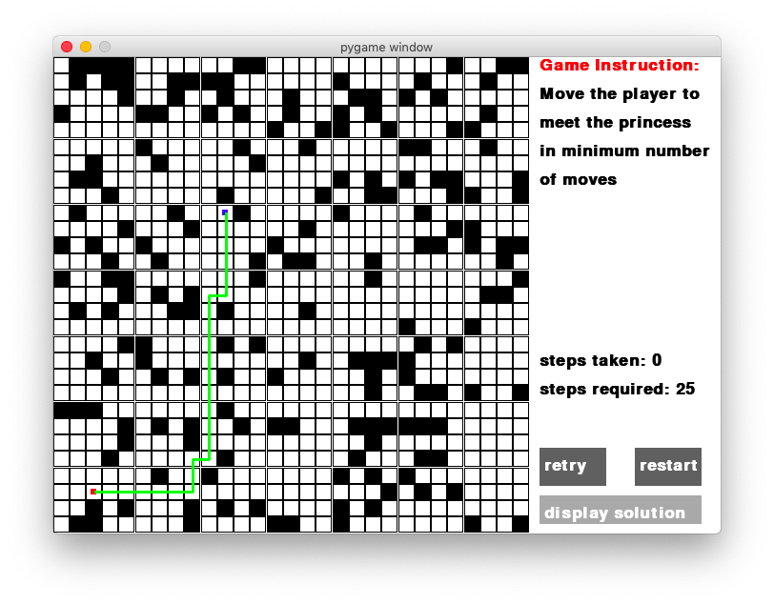

A green path is displayed when the button is held.

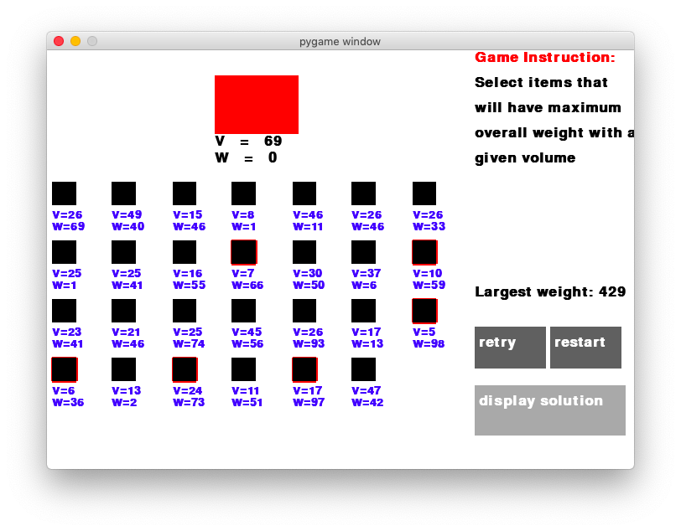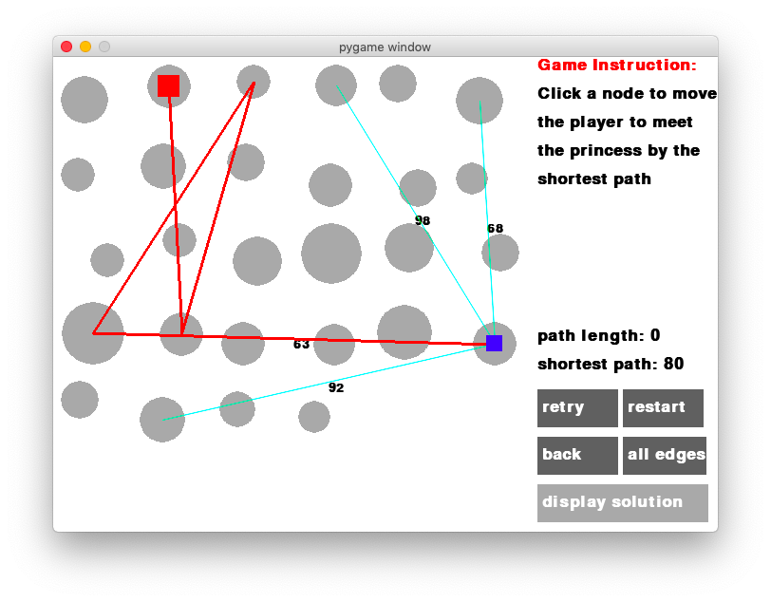

Items need to be selected will be shown.

Similarly, a path will be highlighted when the button is pressed.

### Having seen a similar problem is helpful but not essential to be able to play

This requirement has also been met, and in fact, it is strongly related two of the success criteria. As long as the game has a clear instruction and all the information required to play the game is available, it would not be too hard for one to understand how to play the game even without much prior experience.

### Future development

In terms of future development, there are some requirements that have not yet been met, but is worth considering in the future.

* Challenges are offered in various levels of difficulty

There are some other varieties of these puzzles where similar techniques can be used but requires some extra bit of thinking. It might be worthwhile to include the level system so that the user can apply what they have learnt from level1 to level2 which are similar problems but takes one step further.

* Some illustrations of characters are included

Rather than squares, some characters may be included to make the game more fun. For example, the first puzzle is called save the princess, so the blue box can be replaced by a picture of knight and the red box a picture of princess.

## Usability features

There are also some usability features involved in this game in order to give users a smoother experience. One of them is to implement all functions that are necessary. This is primarily achieved by buttons.

There are three buttons that are common to all three puzzles – retry, restart and display solution. These three buttons will give three basic functions, i.e. try the game again with the same or different settings and look at the solution.



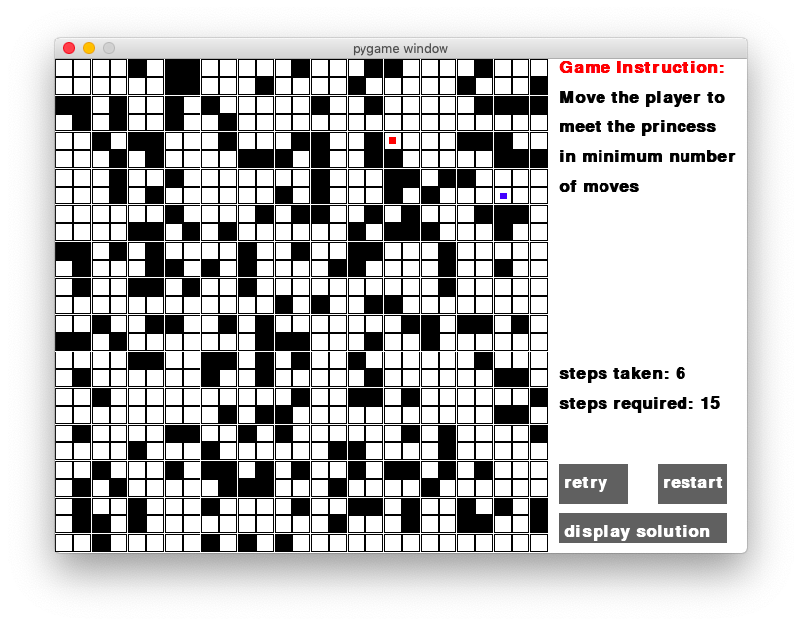For example, in the first puzzle, saving the princess. If the user wants to go back to the original position at this stage, he can simply press the retry button.

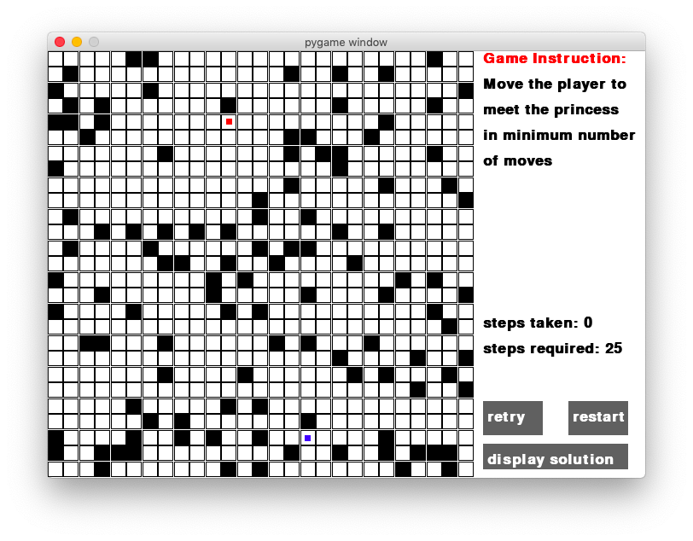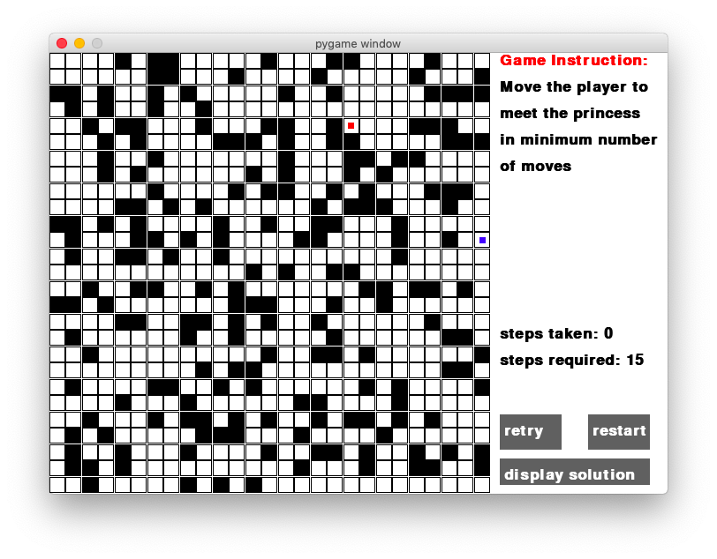And the restart button gives a whole new maze.

The position and the step have been reset.

In the second puzzle, some extra buttons with functions specific to this puzzle are added, including the back button that enables the user to go back one step when he/she makes a mistake; the all edges button can give a peek of the layout of the graph with all edges displayed.

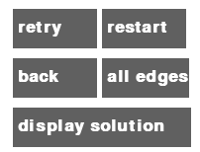

Effect of the all edge button: (may not be as useful when the number of edges become large)

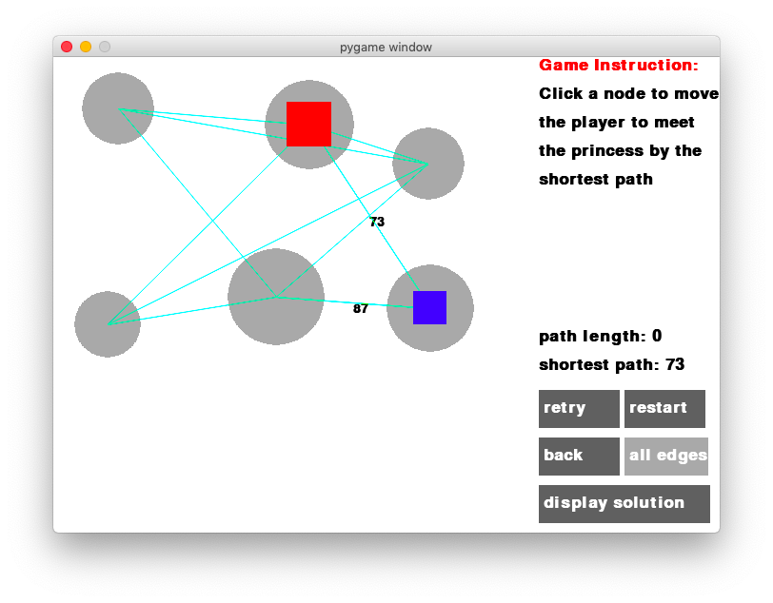

In the third puzzle, there is not any extra buttons, but the ability of right clicking to deselect items also makes it easier for the user to undo moves.

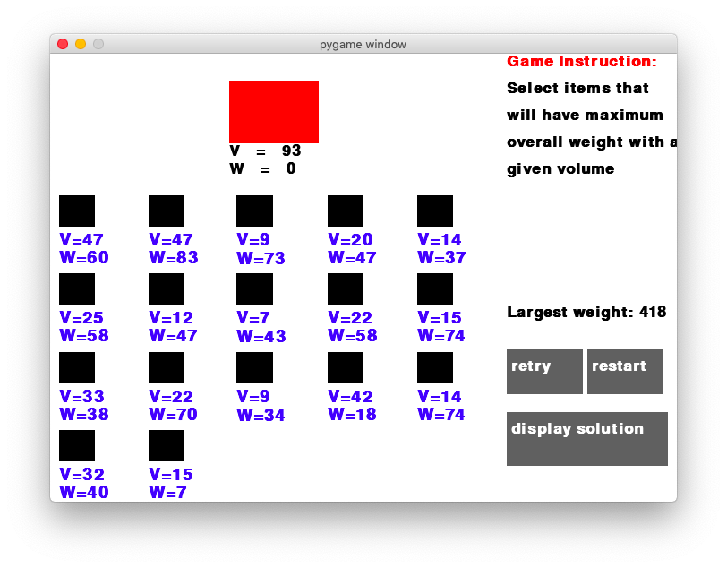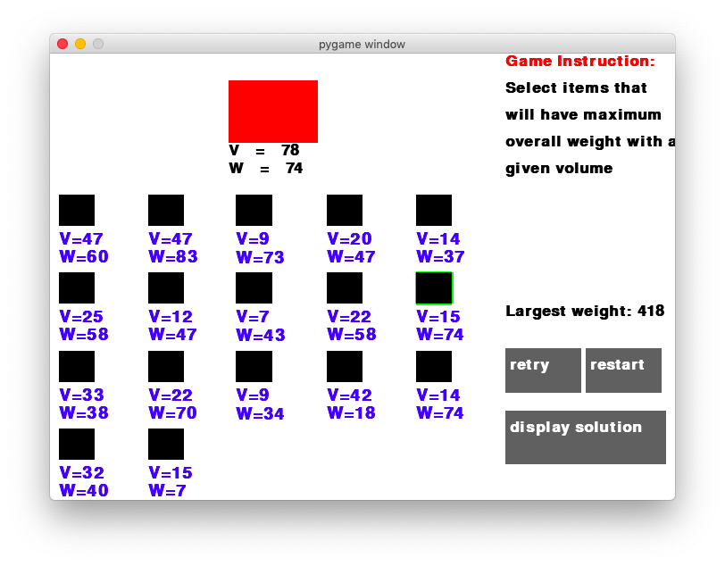

It will then be deselected if one right clicks it.

An item has been selected.

In terms of how this game can be improved to make it more usable in the future, one of the “could” requirements is worth considering: extra guidance provided if a user does not understand the problem. Although game instructions are displayed on the righthand side of each puzzle, it is still possible that the user does not understand the description, in which case some extra explanations are required, maybe a few examples with illustrations. This can be achieved using some pop-up windows and question-mark-like buttons so that once it is clicked, a more detailed explanation of the current game can be displayed and help the user gain more information of the game.

## Limitations and maintenance

### Issues

Two major limitations of this game, which were mentioned at the analysis stage, are the lack of formal theories and fancy visual effect.

The lack of theories is determined by the characteristic of this game, which is to provide an interactive game to learners who want to learn some of the advanced algorithms, and there are lots of detailed explanation of how these algorithms work mathematically and theoretically, and therefore this would not be included in this game, which means this game is not a comprehensive learning tool and needs to be used along with some theory books, etc.

Secondly, fancy visual effects are not included in this game. Some of the coding websites provide good visual effects that can give users the experience of playing real games. But again, this is not the main focus of this game and learners may feel that this game is not as interesting as some of those online learning platforms.

There are also some maintenance issues with this game if it was to be developed in the future.

Firstly, the code logic might experience change in the future. During my development cycle, there has been several times of change of code logic, e.g. the relationship between different classes, although it has been modified several times and is now much more consistent than before. It is still likely that better logic will be developed in the future and that can cause problems as this means many changes to current codes need to be made.

Secondly, the enlargement of the screen can cause some problems. Currently, the size of the screen is decided arbitrarily and so are the positions of elements on the screen. Lots of numerical values are used as position parameters. When the screen is enlarged, those parameters will be adjusted again in order to fit in the new screen.

Lastly, as puzzles are relatively of each other, it is not easy to reuse codes if new puzzles were to be developed in the future, especially puzzles of new styles. For example, if a new path-finding algorithm is going to be introduced, then the Node class can be reused. However, if some algorithms that involves computational geometry are introduced, then not many current codes can be reused.

### How to address them

There are some ways to deal with the limitations and issues mentioned above.

In order to make this game more comprehensive in terms of its educational aspect, some references can be included, with the permission of authors, to give users some indication of what to look at if they want to study formally the theory behind these games. This can make the game more helpful to some of the beginners in this area.

Better visual effects can always be included if needed. As mentioned the future development, some pictures can be used to replace squares to make the game more interesting, and other effects as well such as smooth move of the player, etc.

In terms of maintenance, first of all, the use of numerical values as position parameters needs to be changed to variables. This makes the enlargement of the screen easier and even resizable screen can be developed in the future. Moreover, it is also important to have a detailed plan of what kind of puzzles will be included, as the code logic will need to be considered carefully before adding new things so that better logic can be applied first. This could also potentially make the code more reusable if OOP was used properly in the code.